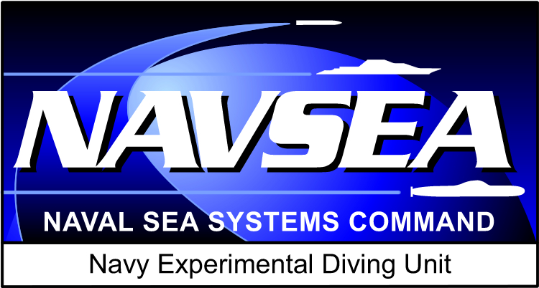

Navy Experimental Diving Unit   
(NEDU)

The World’s leading center for diving research, including equipment testing and evaluation — providing biomedical and engineering solutions for undersea operations

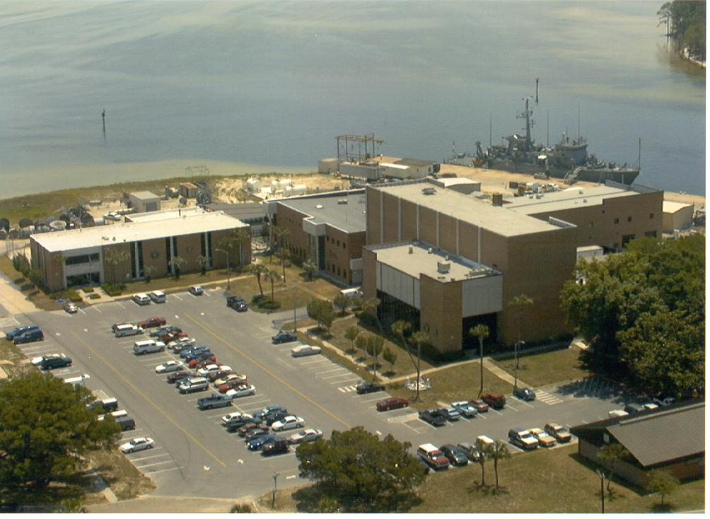

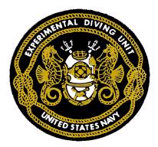

**KEEPING AMERICA’S NAVY #1   
IN THE WORLD**

TABLE OF CONTENTS

|  |  |
| --- | --- |
|  |  |
| 1. **The NEDU Team** | **3** |
| 1. **NEDU Facilities** | **3–7** |
| * Ocean Simulation Facility (OSF) * Open Ocean Diving * NEDU Craft * Test Pool * Unmanned Test Facility * Environmental Chamber * Cardiopulmonary Laboratory * Gas Analysis Laboratory * Specimen Analysis Laboratory * Class 100,000 Clean Room * Technical Library | **3**  **4**  **4**  **4**  **5**  **5**  **6**  **6**  **6**  **7**  **7** |
| 1. **Capabilities** | **8** |
| * Biomedical Research and Development * Diving Systems Testing and Evaluation, Consultation | **8**  **8** |
| 1. **Business Partners** | **9** |
| * Academia * U.S. Government * International | **9**  **9**  **9** |
| 1. **Customers** | **9** |

**The NEDU Team**

* Is composed of 125 **highly** **qualified** and **experienced** military divers and support personnel.
* Our divers come from all Navy diving communities: Sea-Air-Land (SEAL) teams, Explosive Ordnance Disposal (EOD), salvage, saturation, Seabee, Engineering Duty Officer, and Undersea Medical Officer (UMO).
* Has Project Officers in several divisions (EOD, SEAL, Fleet), with a focus on operational and mission needs.
* Includes a professional staff of military and civilian physiologists and psychologists and Diving Medical Officers (DMOs), a total of 13 Ph.D. scientists, 8 engineers, and many others with science degrees.
* Provides worldwide medical and technical consultation with DMOs 7 days a week, 24 hours a day.
* Services customer needs with more than **1,000 man-years** of diving experience.

**NEDU Facilities**

###### **Ocean Simulation Facility (OSF)**

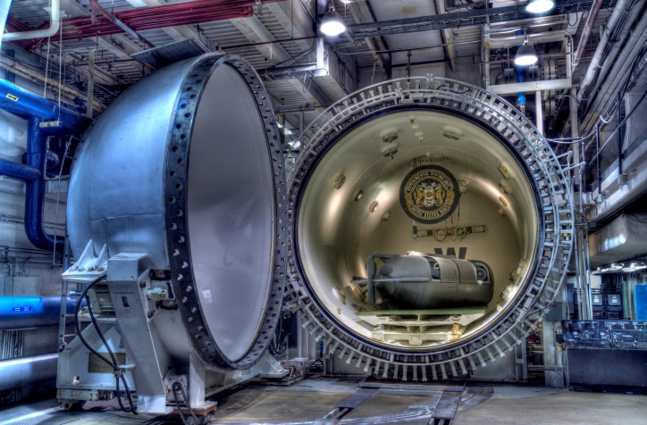The OSF chamber **simulates** **ocean** **conditions** to a maximum pressure equivalent of **2,250 feet of seawater** (fsw). The chamber complex consists of a 55,000-gallon wet chamber and 5 interconnected dry living/working chambers **totaling 3,300 cubic feet**. Wet and dry chamber temperatures can be set from 36 to 104 °F. The OSF has **modern data acquisition** **capabilities,** and its wet chamber can accommodate a wide range of research and development activities such as **diver** **biomedical** studies and **complex** **man-machine** testing. Saturation dives can be performed in the OSF for **more than 30 days** of **continuous exposure**. The dry chambers, which can also serve as facilities for **altitude** **simulation** studies to 150,000 feet, provide a comfortable living environment for diver-subjects when they are not performing underwater excursions to test men and equipment for extended periods in the wet chamber.

###### 

###### **Open Ocean Diving**

NEDU's **close proximity** to **St. Andrews Bay** and **the Gulf of Mexico** (less than five miles)—combined with **mild year-round weather**, **good underwater visibility**, and **various bottom types/depths—**makes us an **ideal research facility** when open ocean diving is desired.

###### **Test Pool**

The **15-foot-deep** test pool can maintain temperature ranges from 34 to 105 °F. Equipped with data acquisition instrumentation, the test pool is used for conducting a diverse range of studies including tests of **diver physiology** and tests/evaluations of **manned diving equipment** and **small submersible vehicles**.

###### **NEDU Craft**

NEDU **owns and operates two boats, a 27-foot Boston Whaler and an F-470 Zodiac**. With two 225 HP outboard engines, the Boston Whaler has a 70 nautical mile range. It can **support** many **open water functions** as well as **transport 10 divers and all associated equipment**. NEDU provides operational support to the various research organizations at Naval Support Activity (NSA), Panama City, FL. The Zodiac has a 30 HP outboard engine and is used to support a wide range of operations conducted by Naval Special Warfare and Navy Special Operations (EOD) divers.

***Unmanned Test Facility***

The unmanned test facility is equipped with data acquisition instrumentation, three hyperbaric chambers, three breathing machines that simulate diver-breathing patterns, and several mannequins. This facility’s hyperbaric chamber complex is available for **unmanned testing to 1,640 fsw** over a temperature range from 28 to 110 °F. Research capabilities include **freeze studies and work of breathing tests,** as well as **carbon dioxide absorbent duration** and **oxygen consumption tests** for closed-circuit underwater breathing apparatus (UBAs). A one atmosphere laboratory is dedicated to testing non-diving life support equipment.

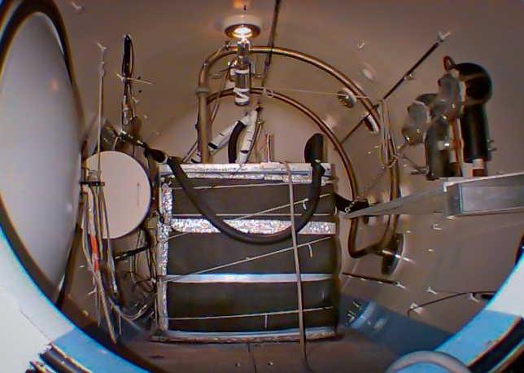

Environmental Chamber

The environmental chamber is capable of **simulating** a broad range of **temperatures** (0 to 130 °F), **humidity’s** (5 to 95%), and **wind conditions** (0 to 20 mph). The chamber is instrumented to conduct **physiology** **studies** and test **diving equipment and respiratory and thermal protective equipment.**

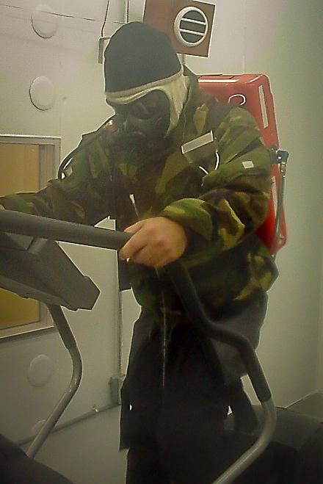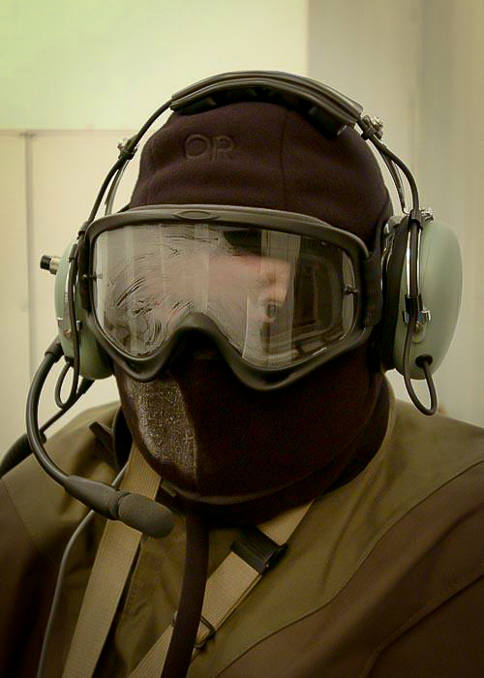

###### 

###### **Cardiopulmonary Laboratory**

Associated with the environmental chamber, the cardiopulmonary laboratory conducts a myriad of **respiratory function tests** and **aerobic performance measurements**.

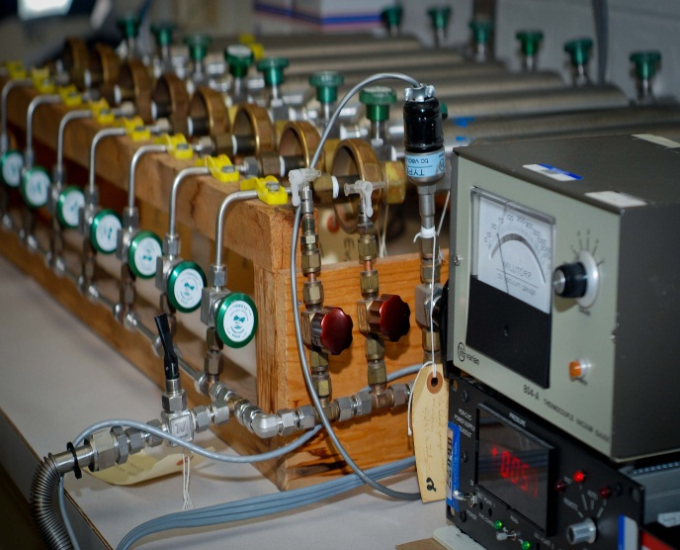T

***Gas Analysis Laboratory***

The gas analysis laboratory allows **precision analysis of gases** and **evaluates diving-related problems**,with **rapid turnaround for the Fleet**. The laboratory’s analytical capabilities include **gas** **chromatography, mass** **spectrometry,** and **infrared** **spectroscopy**. Current emphasis is on developing field-based screening methods and analyzers for use in the Fleet.

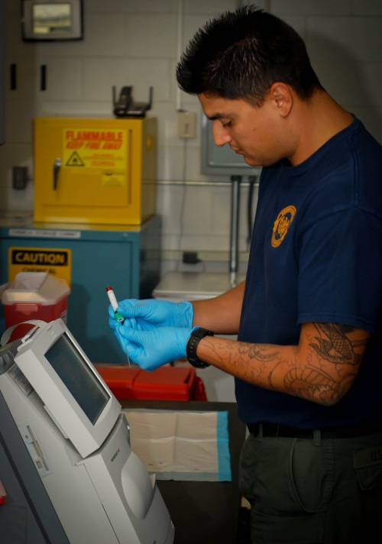

###### **Specimen Analysis Laboratory**

To support various diving research projects, the specimen analysis laboratory ensures **precise analysis of specimens. Highly qualified technicians** provide **blood** **chemistry, urinalysis,** and **hematology** test results.

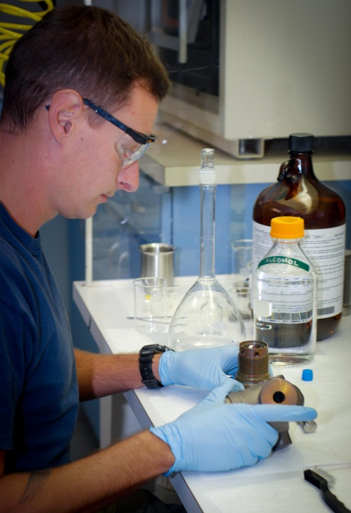

###### **ISO Class 8 Clean Room**

###### NEDU maintains an ISO Class 8 Clean Room, operated by **certified** **technicians** who perform a variety of cleaning and testing tasks: **oxygen cleaning of piping, valves, regulators, tanks, gauges** and **filters —** as well as **hydrostatic testing** up to 10,000 psi and calibration of analog gauges. All components used in diving life-support systems are cleaned and certified to **meet Military Standard (MIL-STD) 1330D**.

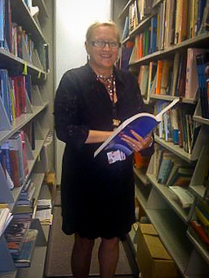Capabilities

###### **Technical Library**

NEDU houses **one of the world’s largest technical libraries of diving information**. It has more than **150,000 documents** on diving **history, engineering,** and **medicine.** Much information covers the early development of various diving tables. Researchers from around the world, both inside and outside the diving community, use the archives and resources of the library.

###### **Biomedical Research and Development**

* Biomedical Instrumentation Design, Development, and Testing
* Contaminated Water Diving Procedures, Equipment, and Guidance
* Decompression Algorithm and Table Development
* Development of Procedures for Treating Decompression Sickness
* Environmental Stress Evaluation, Intervention, and Guidance
* Gas Analysis Methods and Procedures
* Human Performance Assessment in Thermal and Hyperbaric Conditions
* Oxygen Toxicity Risk Assessment
* Respiratory Mechanics Evaluation, Intervention, and Guidance

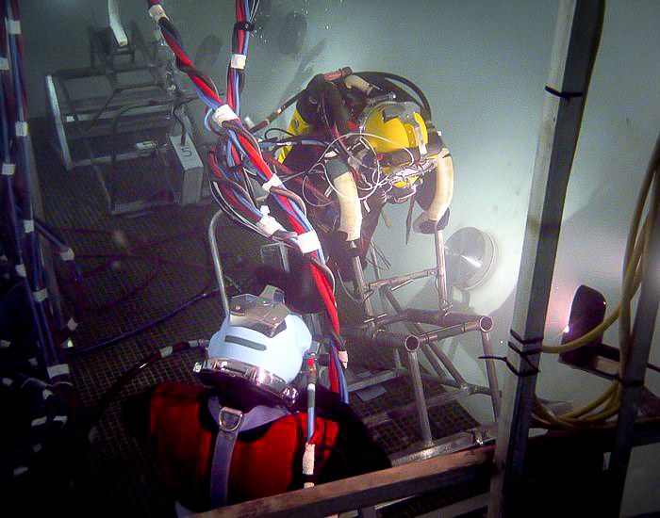

###### **Diving Systems Testing and Evaluation, Consultation**

|  |  |  |
| --- | --- | --- |
| * Diving and Hyperbaric Communication Systems | * Diving and Deep Submergence Equipment | |
| * Breathing Life-Support Systems * Modeling and Simulation | * Evaluation of Systems for Oxygen Use | |
| * Oxygen Cleaning | * Hyperbaric Medical Equipment | |
| * One-Atmosphere Suits and Dive Systems | * Open and Closed-Circuit, and Surface-Supplied UBAs | |
| * Hyperbaric Life-Support Systems | * ROV/Submersible Testing to 2,250 fsw | |
| * UBA Equipment Accident Investigation | * Underwater/Hyperbaric Electrical Safety | |
|  | |  | |

***Business Partners***

|  |  |  |
| --- | --- | --- |
| ***Academia*** | ***U.S. Government*** | |
| * Duke University | * National Aeronautics and Space Administration | |
| * Florida State University | * National Oceanic and Atmospheric Administration | |
| * John Hopkins University | * Naval Aerospace Medical Research Laboratory | |
| * University at Buffalo | * Naval Air Systems Command | |
| * University of North Carolina | * Naval Medical Research Center | |
| * University of Pennsylvania | * Naval Research Laboratory | |
| * University of Wisconsin | * Naval Submarine Medical Research Laboratory | |
| * University of West Florida | * Naval Support Activity, Panama City | |
| * Naval Postgraduate School | * Navy Diving and Salvage Training Center | |
|  | * Uniformed Services University of Health Services | |
|  | * Office of Naval Research * Army Corp of Engineers * U. S. Special Operations Command | |
| International | | |  | |
| * ABCANZ (America-Britain-Canada-Australia- New Zealand) Diving Group * The Technical Cooperation Program (TTCP) MAR 13— USA, UK, Canada, NZ, and Australia | * Defense Evaluation Research Agency (DERA), United Kingdom * Defense Science and Technology Laboratory, United Kingdom |
| * Defense Research and Development Canada (DRDC) | * International Program Office (IPO),Germany and Israel |
| * NATO STANAG Underwater Diving Working Party (UDWP 1311) |  | | |

*Customers*

|  |  |
| --- | --- |
| * U.S. Marine Corps Special Operations Command (USMARSOC) | * Chief of Naval Operations Deep Submergence  (CNO N773) |
| * Defense Research and Development Canada (DRDC) | * National Aeronautics and Space Administration (NASA) |
| * Naval Special Warfare (PMS-NSW) * Office of Naval Research (ONR) * U.S. Special Operations Command (USSOCOM) * U.S. Coast Guard * Navy Special Operations (PMS-EOD) * U.S. Air Force * U.S. Air Force Special Operations Command (USAFSOC) | * U.S. Army * Naval Sea Systems Command Deep Submergence (PMS-399, PMS-394) * U.S. Army Special Operations Command (USASOC) * U.S. Army Corps of Engineers * U.S. Marine Corps * Bureau of Medicine and Surgery (BUMED) * National Institute of Occupational Safety and Health (NIOSH) * Naval Sea Systems Command, Office of the Director of Ocean Engineering, Supervisor of Salvage and Diving (NAVSEA 00C) |