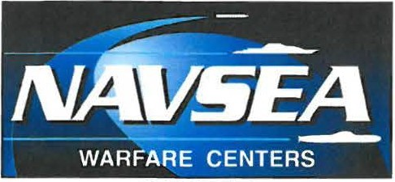
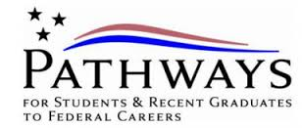
CRA NE

Pathways Internship Program
The new Internship Program provides students in high schools, colleges, trade schools and other qualifying educational institutions with paid opportunities to work in agencies and explore Federal careers while completing their education.

Eligibility
Current students in an accredited high school, college (including 2-year or 4-year colleges/universities, community colleges, and junior colleges); professional, technical, vocational, and trade school; advanced degree programs ; or other qualifying educational institution pursuing a qualifying degree or certificate.

Program Administration
- Interns may be hired on a temporary basis for up to one year for an initial period, or for an indefinite period, to complete the educational requirement.
- Interns may work either part- or full-time.
- Each agency must sign a Participant Agreement with the Intern that sets forth the expectations for the internship.
- All Intern positions will be related to the Intern's academic career goals or field of study.

Program Completion and Conversion
Interns may be converted to a permanent position (or, in some limited circumstances, to a term position lasting 1-4 years) within 120 days of successful completion of the program.

To be eligible for conversion, Interns must:
- Complete at least 640 hours of work experience acquired through the Internship Program (may be waived under certain circumstances)
- Complete their degree or certificate requirements
- Meet the qualification standards for the position to which the Intern will be converted. Meet agency-specific requirements as specified in the Participant's Agreement.
- Perform their job successfully.
- Time spent under previous Federal Internship Program appointments may count towards required work experience hours.

Program Highlights
Applicants must be:
- U.S. Citizens
- Enrolled or accepted for enrollment as a degree-seeking student with a major field of study in a science,
- engineering, technology, or business discipline
- Must be able to work a minimum requirement of 16 weeks (640 hours) prior to graduation.
- Must remain in academic good standing
- Salary based on completion of academic semester hours.

For more information about NSWC Crane: http://www.navsea.navy.mil/Home/WarfareCenters/NSWCCrane.aspx

https://www.facebook.com/NSWCCrane

Sign-up to receive email alerts when Pathways positions are posted at https://www.usajobs.gov/

