10th International Heat Flow calorimetry Symposium on Energetic materials
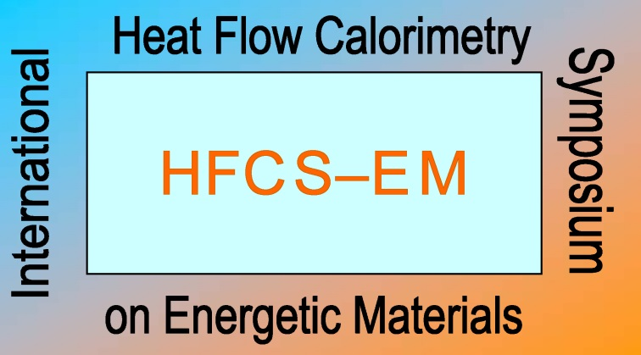

Main Topics:
- Decomposition kinetics of energetic material – mechanisms, kinetic descriptions
- Experimental methods, problems, solutions, developments
- Instrumental improvements and innovations
- Measuring heat changes from chemical reactions or physical events
- Surveillance study using HFC
- Testing high explosives, propellants and pyrotechnics by HFC
- HFC for stability and compatibility testing of explosives and materials
- Regulations and standards
- Other thermal methods (DSC, ARC, etc)

Date: 25-28 September 2017 // Place: Crane, IN USA // Host: Naval Surface Warfare Center, Crane Division (NSWC Crane)

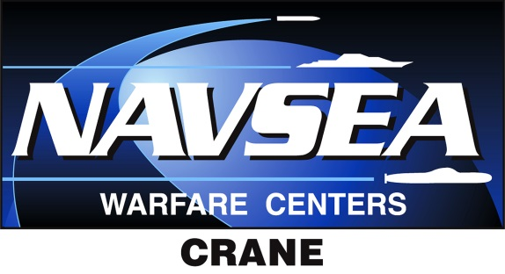

Program Overview
Monday 25 September 2017
18:00-19:30 Informal welcome meeting and registration at Hyatt Bloomington
Tuesday 26 September 2017
08:00 Coach departure from Hyatt Bloomington
*Be prompt, access to the venue cannot be guaranteed by any other means of transportation*
09:00 Welcome and Opening Remarks
09:15-10:00 Scientific sessions
10:00 Vendor Exposition Break
10:45-11:45 Scientific sessions
12:00 Lunch at Club Lakeview
13:00-1400 Scientific Sessions
14:00 Vendor Exposition Break
14:45-1530 Scientific Sessions
15:30 Vendor Exposition Break and Splinter Group Meetings
16:15 Coach transportation return to Hyatt Bloomington
17:30 Social Program:……………
Wednesday 27 September 2017
08:00 Coach departure from Hyatt Bloomington
*Be prompt, access to the venue cannot be guaranteed by any other means of transportation*
09:00 -10:00 Scientific sessions
10:00 Vendor Exposition Break
10:45-11:45 Scientific sessions
12:00 Lunch at Club Lakeview
13:00-1400 Scientific Sessions
14:00 Vendor Exposition Break
14:45-1600 Scientific Sessions
16:00 Vendor Exposition Break and Splinter Group Meetings
16:30 Conference Dinner
19:00 Coach transportation return to Hyatt Bloomington
Thursday 28 September 2017
08:00 Coach departure from Hyatt Bloomington
*Be prompt, access to the venue cannot be guaranteed by any other means of transportation*
09:00 -10:00 Scientific sessions
10:00 Vendor Exposition Break
10:45-11:45 Scientific sessions
12:00 Lunch at Club Lakeview
13:00 Closing Remarks
13:15 Tour of NSWC Crane
15:30 Coach Transportation return to Hyatt Bloomington
17:00 Social Program……………………….

