

**STEM Unit: Seaplanes**

**General Studies Curriculum Overview**

**Approximately 1800 minutes**

**Overview of Unit**: At CESJDS our fourth grade students spend 6-8 weeks working on a research project that involves reading, writing and in-depth research about an inventor from the Industrial Era. Using the CESJDS inquiry model, students explore texts and online resources to help build an understanding not only of an inventor but of the Industrial Era as a whole. The research culminates with student-created websites that shares each student’s research in a new and different way.

**Essential Questions:** How does innovation bring about change in politics and society? How did inventors such as the Wright Brothers, George Washington Carver, Alexander Graham Bell, and Thomas Edison change society?

**Standards addressed within 6-8 week unit:**

**Reading & Writing Standards (source: http://www.corestandards.org/ELA-Literacy/W/4)**

[CCSS.ELA-Literacy.RI.4.1](http://www.corestandards.org/ELA-Literacy/RI/4/1/) Refer to details and examples in a text when explaining what the text says explicitly and when drawing inferences from the text.

[CCSS.ELA-Literacy.RI.4.2](http://www.corestandards.org/ELA-Literacy/RI/4/2/) Determine the main idea of a text and explain how it is supported by key details; summarize the text.

[CCSS.ELA-Literacy.RI.4.3](http://www.corestandards.org/ELA-Literacy/RI/4/3/) Explain events, procedures, ideas, or concepts in a historical, scientific, or technical text, including what happened and why, based on specific information in the text.  
[CCSS.ELA-Literacy.W.4.7](http://www.corestandards.org/ELA-Literacy/W/4/7/) Conduct short research projects that build knowledge through investigation of different aspects of a topic.  
[CCSS.ELA-Literacy.W.4.8](http://www.corestandards.org/ELA-Literacy/W/4/8/) Recall relevant information from experiences or gather relevant information from print and digital sources; take notes and categorize information, and provide a list of sources.  
[CCSS.ELA-Literacy.W.4.2a](http://www.corestandards.org/ELA-Literacy/W/4/2/a/) Introduce a topic clearly and group related information in paragraphs and sections; include formatting (e.g., headings), illustrations, and multimedia when useful to aiding comprehension.  
[CCSS.ELA-Literacy.W.4.2b](http://www.corestandards.org/ELA-Literacy/W/4/2/b/) Develop the topic with facts, definitions, concrete details, quotations, or other information and examples related to the topic.  
[CCSS.ELA-Literacy.W.4.2d](http://www.corestandards.org/ELA-Literacy/W/4/2/d/) Use precise language and domain-specific vocabulary to inform about or [CCSS.ELA-Literacy.W.4.2e](http://www.corestandards.org/ELA-Literacy/W/4/2/e/) Provide a concluding statement or section related to the information or explanation presented.

**Social Studies Standards (source: Maryland State Social Studies Standards www.mdk12.org)**

**Standard 4.0 Economics**

Students will develop economic reasoning to understand the historical development and current status of economic principles, institutions, and processes needed to be effective citizens, consumers, and workers participating in local communities, the nation, and the world.

* **4.A.3** Explain how technological changes have affected production and consumption in Maryland

**Standard 5.0 History**

Students will examine significant ideas, beliefs, and themes; organize patterns and events; and analyze how individuals and societies have changed over time in Maryland and the United States.

* **5.2**  Explain the political, cultural, economic and social changes in Maryland during the early 1800s

**Standard 6.0 Social Studies Skills and Processes**

Students shall use reading, writing, and thinking processes and skills to gain knowledge and understanding of political, historical, and current events using chronological and spatial thinking, economic reasoning, and historical interpretation, by framing and evaluating questions from primary and secondary sources.

* **6.B.1.** Use informal writing strategies, such as journal writing, note taking, quick writes, and graphic organizers to clarify, organize, remember and/or express new understandings
* **6.3**  Use strategies to monitor understanding and derive meaning from text and portions of text (during reading)
* **6.E.2.** Organize information from print sources
* **6.F.1.** Interpret information from primary and secondary sources
* **6.F.2.** Evaluate information from a variety of sources

##### 6.F.****3**.** Synthesize information from a variety of sources

*The following lessons took place during the first week of the 6-8 week unit. Teachers used resources about Glen Curtiss to model the initial stages of the research process.*

**Lesson 1- Content Lesson: Building background knowledge**

During this lesson teachers help students connect their knowledge about the Civil War (the previous unit) and the changes in society at the beginning of the Industrial Era. Teachers had students study photographs from the time period as well as read to the students about the Industrial Era. This lesson was also used to introduce key vocabulary of the time period.

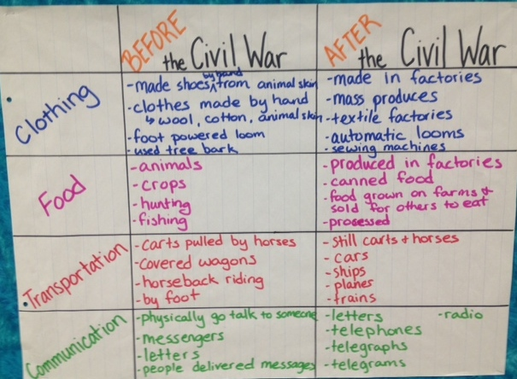 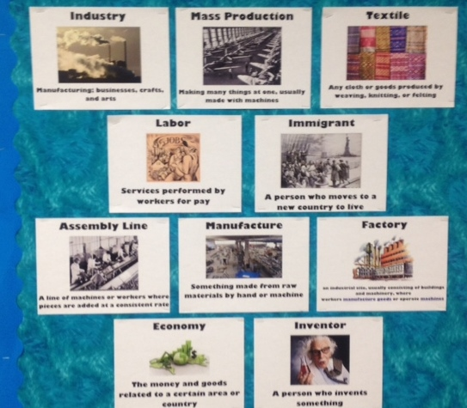

**Lesson 2- Reading Research Strategy: Skimming and Scanning**

Using the text *The Story of Flight: Seaplanes and Naval Aviation* by Ole Steen Hansen, teachers modeled how skimming and scanning can be an efficient way to locate information. Students were then given excerpts from this same text to practice skimming and scanning independently.

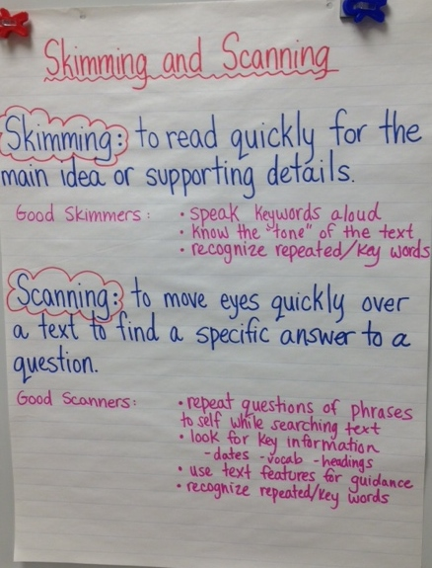

**Lesson 3- Reading Strategy: Text Features**

Teachers used the texts *10 Inventors Who Changed the World* and *The Story of Flight: Seaplanes and Naval Aviation* to demonstrate how readers use text features to navigate a text. Using table of contents, indices, titles and headings, teachers modeled how when doing research using these text features helps to find certain information quickly.

**Lesson 4-Reading Strategy: Close reading of key passages**

Using the text *Glenn H Curtiss: Architect of American Aviation* teachers modeled how good researchers re-read closely parts of the text that are rich with important information. Students worked independently to practice the skill of close reading while learning about Glenn Curtiss. They then shared the salient information from the passages they read.

**Lesson 5-Research Strategy: WOW Facts**

Teachers used a variety of texts to model how researchers find new and interesting information (WOW facts) and make note of them as they research. These Wow facts are collected throughout the project as students learn more about their inventor. Teachers use different texts about Glenn Curtiss to model the importance of paying attention to WOW facts as they research.

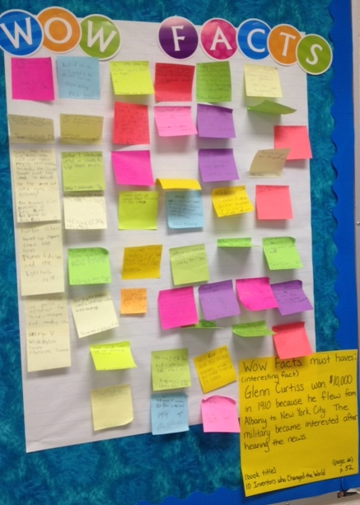

**Industrial Era Research Lab Rubric**

**Essential Questions:**

*How does innovation bring about change in politics and society?*

*How did inventors such as The Wright Brothers, George Washington Carver, Alexander Graham Bell, and Thomas Edison change society?*

|  |  |
| --- | --- |
| **Criteria** | Grade |
| **Content Standards** |  |
| A combination of photographs, pictures, video and/or audio are used to support text |  |
| Information is shared with relevant details and facts |  |
| All information and visual content are cited correctly from a variety of sources and media |  |
| All relevant research questions have been addressed |  |
| Information demonstrates understanding of time period |  |
| **Writing Standards** |  |
| Information is shared in an interesting and engaging manner |  |
| Paragraphs are clearly organized and remain on topic (topic sentence, details and/or examples, concluding sentence) |  |
| Sentence structure is varied using complex and simple sentences |  |
| Work is edited for appropriate capitalization, punctuation and spelling |  |
| **Website Layout** |  |
| Website is aesthetically pleasing with clear links to appropriate sections (font is appropriate color and size, background color is not distracting) |  |
| Website includes non-fiction text features to support reader’s understanding of information (headings, bolded words, captions, chart, sidebar) |  |
| Audience is able to navigate pages effectively |  |
| **Work Habits** |  |
| Use of classroom time is focused on project work |  |
| Collaboration with peers is effective and respectful |  |
| Any challenges that were encountered were managed independently |  |
| Managed time to complete project elements |  |

**Comments:**

Grading Scale:

1-Work was consistently produced at a *high-level* within the website and/or during preparation of project.

2-Work was consistently produced according to *grade-level* expectations within the website and/or during preparation of project.

3-Work was *approaching grade-level* expectations within the website and/or during preparation of project.

4-Work *did not meet grade-level* expectations within the website and/or during preparation of project.

ONLINE RESOURCES

Glenn Curtiss Museum

<http://www.glennhcurtissmuseum.org/museum/glenncurtiss.html>

* Detailed biography.

Curtiss NC-4 Flying Boat

<http://goldenageofaviation.org/nc4.htm>

* Good summary of essential information about NC-4.

First Aircraft Across the Atlantic — Curtiss’s NC-4

<http://travelforaircraft.wordpress.com/2011/11/16/curtiss-nc-4-write/>

* Blog post with a great summary of pertinent information, and a number of good photos.

The First Flight Across the Atlantic

<http://web.archive.org/web/20080515221553/http://history.sandiego.edu/gen/WW2Timeline/firstflight.html>

* Detailed background information about the competition for the first transatlantic flight, and the NC-4’s success.

Curtiss NC-4

<http://en.wikipedia.org/wiki/Curtiss_NC-4>

* Detailed Wikipedia entry.

Foynes Flying Boat and Maritime Museum

<http://www.flyingboatmuseum.com/history/>

* Brief aviation timeline

VIDEOS

<http://www.youtube.com/watch?v=K6E696hr420>

* Video with great archival footage of the plane and its 1919 transatlantic trip.

Curtiss NC-4 Flying Boat

<http://www.youtube.com/watch?v=c2Sh08xn0V0>

* Museum photos and archival footage.

PRINT RESOURCES

Gifford, Clive. *10 Inventors who Changed the World.* New York: Kingfisher, c.2009.

* Biography of Glenn Curtiss found on pages 50-53.

Carson, Mary Kay.  *The Wright Brothers for Kids: How They Invented the Airplane.* Chicago: Chicago

Review Press, c.2003.

* Brief biography of Glenn Curtiss found on page 130.

Johnson, Bobby H. *Curitss, Glenn Hammond.* Chicago: World Book Encyclopedia, v. 4, c.2010.

* Biography of Glenn Curtiss.

**STEM Unit: Seaplanes**

**Science Curriculum Overview**

**45minutes**

**Overview of Unit**: At CESJDS our fourth-grade students spend 6-8 weeks working on a research project that involves reading, writing and in-depth research about an inventor from the Industrial Era. Using the CESJDS inquiry model, students explore texts and online resources to help build an understanding not only of an inventor but of the Industrial Era as a whole. In science class, students investigate the science behind a specific invention from the Industrial Era – flight. In particular, students spend two days investigating the four major forces that make flight possible: lift, weight, thrust and drag. Using a game-based exploration, students chart an aircraft’s path by spinning a spinner that lands on lift, weight thrust or drag (see game explanation and spinner materials below).

**Essential Questions:** How do forces combine to make flight possible?

### Learning Objectives:

### Students will:

* Identify and use the four forces of flight
* Collect, organize, and interpret data
* Construct tally table and bar graphs
* Determine the likeliness or probability of success
* Read and write ordered pairs
* Use ordered pairs to plot points on a grid

### Common Core State Standards – Mathematics:

Grade 3, Measurement & Data

* CCSS.Math.Content.3.MD.B.3  
  Draw a scaled picture graph and a scaled bar graph to represent a data set with several categories. Solve one- and two-step ''how many more'' and ''how many less'' problems using information presented in scaled bar graphs. For example, draw a bar graph in which each square in the bar graph might represent 5 pets.

Grade 5, Geometry

* CCSS.Math.Content.5.G.A.1  
  Use a pair of perpendicular number lines, called axes, to define a coordinate system, with the intersection of the lines (the origin) arranged to coincide with the 0 on each line and a given point in the plane located by using an ordered pair of numbers, called its coordinates. Understand that the first number indicates how far to travel from the origin in the direction of one axis, and the second number indicates how far to travel in the direction of the second axis, with the convention that the names of the two axes and the coordinates correspond (e.g., x-axis and x-coordinate, y-axis and y-coordinate).

Grade 5, Geometry

* CCSS.Math.Content.5.G.A.2  
  Represent real world and mathematical problems by graphing points in the first quadrant of the coordinate plane, and interpret coordinate values of points in the context of the situation.

**Next Generation Science Standards Alignment:**

* **3-PS2-1:** Plan and conduct an investigation to provide evidence of the effects of balanced and unbalanced forces on the motion of an object.
* **4-PS3- 4:** Apply scientific ideas to design, test, and refine a device that converts energy from one form to another.
* **5-PS2-1:** Support an argument that the gravitational force exerted by Earth on objects is directed down.

**Assessment:**

* Students were assessed through verbal discussions and teacher observations of their data as it demonstrates an understanding of the forces.
* Students completed an “Exit Ticket” with the question: “Which force of flight do you think is the hardest for engineers to create an effective design to account for? Why?”.

**Curriculum Materials:**

**Rescue Mission Flight Game**

**Objective:** To be able to name the four forces of flight and describe how those forces affect an aircraft’s motion.

**\*Remember*:** Flight is possible because of 4 forces that act on an aircraft.

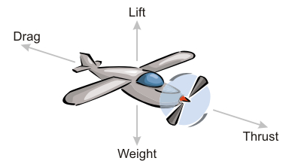

**Lift:** The upward force due to the air’s motion across the wings

**Weight:** The downward force due to gravity

**Drag:** The backward force due to air resistance

**Thrust:** The forward force by the jet engines or propellers

**Directions:** Using your assigned spinner, spin 50 times and chart the results in the tally table below. As you tally, chart the aircraft’s motion on the game board.

**Tally Chart**

|  |  |  |  |
| --- | --- | --- | --- |
| **Lift**  **(one space up)** | **Weight (one space down)** | **Drag**  **(one space backward)** | **Thrust**  **(one space forward)** |
|  |  |  |  |

**Flight Mission Game Board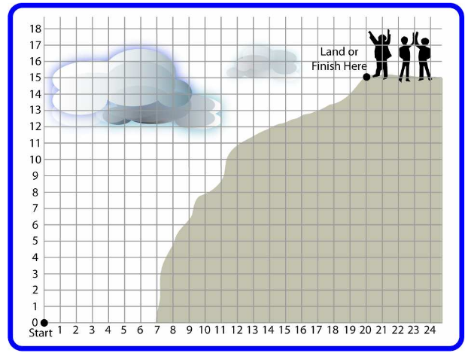Note: If your spins take you off of the grid, then make a tally, but don’t position your aircraft off the grid.**

**Flight Spinners**

When each group uses a different spinner, various probabilities for motion are created. Groups should come together in the end to discuss how the different spinners (probabilities), used over a number of trails, created different flight paths.

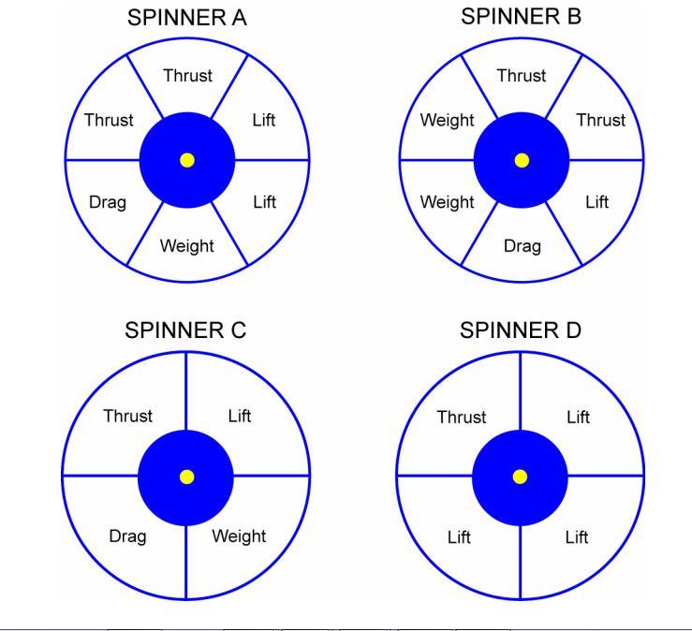

**STEM Unit: Seaplanes**

**Math Curriculum Overview**

**5 class periods (255 minutes)**

**Overview of Unit**: At CESJDS our fourth-grade students spend 6-8 weeks working on a research project that involves reading, writing and in-depth research about an inventor from the Industrial Era. Using the CESJDS inquiry model, students explore texts and online resources to help build an understanding not only of an inventor but of the Industrial Era as a whole. In math class, students cut out, assemble, test, measure, compare, and refine a model of a sea plane.

**Essential Questions:** How can we create a model plane? What can we understand from test flights to guide us in making alterations to the plane? How do engineers use models and mathematics in realizing their goals?

### Learning Objectives:

### Students will:

* Read detailed instructions to cut pieces and assemble the plane
* Interact with each other, teachers, and engineers to solve problems
* Test the plane and measure its flight

### Common Core State Standards – Mathematics:

Grade 4

* CCSS.MATH.CONTENT.4.MD.B.4

Make a line plot to display a data set of measurements in fractions of a unit (1/2, 1/4, 1/8). Solve problems involving addition and subtraction of fractions by using information presented in line plots. For example, from a line plot find and interpret the difference in length between the longest and shortest specimens in an insect collection.

* CCSS.MATH.CONTENT.4.OA.A.2

Multiply or divide to solve word problems involving multiplicative comparison, e.g., by using drawings and equations with a symbol for the unknown number to represent the problem, distinguishing multiplicative comparison from additive comparison.

**Assessment:**

* Students were assessed by their engagement in the activity, verbal discussions, and the quality of their plane in the dimensions that show understanding of measurement and use of measurement tools.
* Students were assessed in their ability to measure the distance of their plane in fractional units of a meter and comparing the distances of the flights of the planes built by their classmates (ie. “Jill’s plane went 1 ¼ meters. This is 3 times further than Billy’s. Billy changed his design and then it went twice as far as Jake’s.”).

***Instructions for the Sea Plane came from the Sea Plane Project.***

**Fourth Grade Field Trip to Baltimore Museum of Industry**

[**http://www.thebmi.org/**](http://www.thebmi.org/)

**300 minutes**

Students did an activity creating roller coasters. They had two foam pieces, 3 marbles (different sizes), and masking tape. They discussed the engineering process. They worked in teams to develop each roller coaster to meet four different design models. They needed to get their model approved by the instructor before moving ahead to the next plan.

Second, they formed an assembly line and made paper cars. They discussed how Ford’s invention of the assembly line helped the people during the Industrial Era. They talked about key vocabulary. They saw a short video about assembly lines. (See material at the end created by the BMI for more details.)

Finally, they toured the museum in small groups (15 students). The museum employee asked and answered questions.

They saw exhibits of:

* printing press
* garment factory - textile industry
* pharmacy and with lunch counter
* Cannery oysters
* Ford exhibit
* blacksmith shop

**Invention Convention**

**At Home Project**

**Essential Questions:** What are engineering problems we find in our everyday lives? How can we create something to solve them?

**Learning Objectives:**

Students will:

* Contemplate other’s “inventions” and explore possibilities for themselves to become an “inventor”
* Interact with the engineering design process (as presented by the Engineering is Elementary curriculum in use elsewhere in the school)
* Create an invention of their own thoughts and design.
* Present their invention at a display explaining their thinking and their project that will be visited by parents

**Assessment:**

* Students are assessed on their participation, logical thought, reflective description of their process, and the quality of the challenge they presented for themselves in their problem solving.

Name: ________________

4th Grade Invention Convention

Is there a problem you want to solve?

Do you get bored with your toys at home?

Is there something that really bugs you?

Do you want to make something easier to do?

Do you wish something you use worked a little differently?

If so, use you imagination and create an invention that will solve your problem. You may make a working model or a non-working model of your invention.

Working Model: An invention that really works! Be prepared to demonstrate how it works for the class.

Non-Working Model: Maybe you have a great idea, but you are not able to put it together. No problem! Make a model of your invention using legos or some other materials.

Read over the next few pages to learn more about this project and to get some ideas.



**Project Due Date: Wednesday, April 2nd**

Parents, please save the date!

Invention Convention: Thursday, April 3rd - 8:30am

**Not sure what to invent? Here are some ideas:**

* ADAPTATIONS: Take a product that has already been invented, and improve it.

* ENVIRONMENT: We need help to make our environment better for everyone. Can you think of an invention that would help make the world better for animals, plants and people? The world would be grateful if you could!

* http://pbskids.org/designsquad/projects/

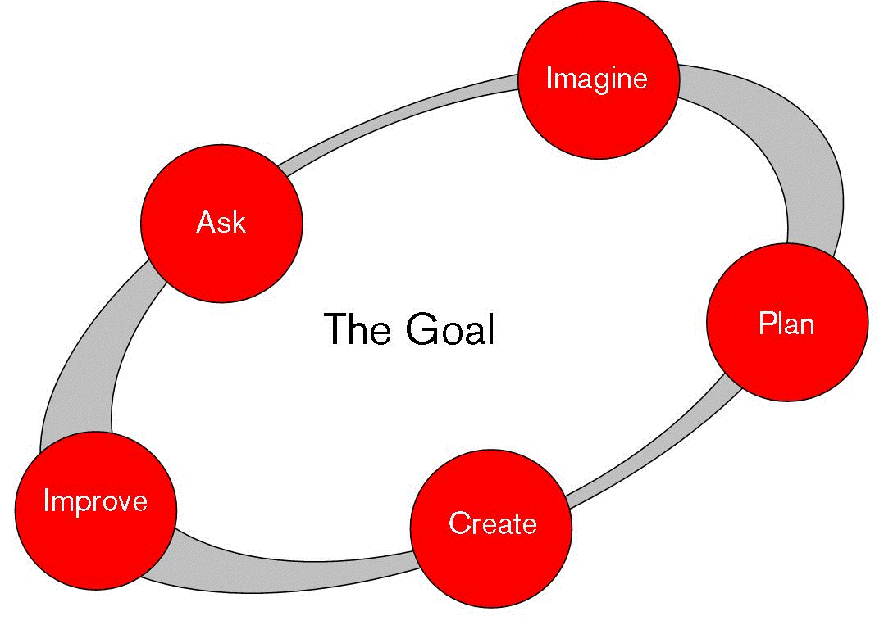Engineering Design Process

Here are the steps you will follow to complete this project:

1.) Brainstorm an idea. Write down any of your ideas below. (Due: Friday, March 14th)

2.) What did you decide on? Describe or draw a picture of your invention. Does it have a name? (Due: Wednesday, March 19th)

________________________________________________________________________________________________________________________________________

____________________________________________________________________

3.) How are you planning to make it? What materials or resources do you need to make it? (Due: Tuesday, March 25th)

__________________________________________________________________________________________________________________

4.) Create a tri-fold poster board that talks about **your invention and how you created it using the engineering design process**. Things you might want to include on your board:

* pictures of yourself building it
* advertisement of the product
* detailed description of the product

(Due: Wednesday, April 2nd)

5.) Create your invention. Make a working model or non-working model of your invention.

(Due: Wednesday, April 2nd