Capt. Mark R. Vandroff, USN

Commanding Officer

Naval Surface Warfare Center, Carderock Division
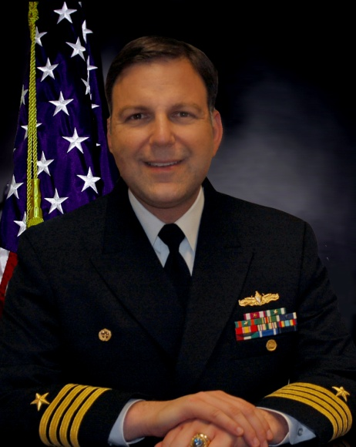
Capt. Mark Vandroff assumed command of Naval Surface Warfare Center, Carderock Division on Sept. 8, 2016. He is the 37th commander to lead the organization since its founding as the Experimental Model Basin in 1898. As commanding officer, Capt. Vandroff leads more than 2,000 employees who provide the Navy a broad range of technical support specializing in hull, mechanical, and electrical engineering.

Capt. Vandroff graduated from the U.S. Naval Academy in 1989 with a B.S. in physics. While at the Naval Academy, he participated in the Voluntary Graduate Education Program. In December 1989, he graduated from The Johns Hopkins University with a Master of Science in applied physics.

His first sea tour was the pre-commissioning crew of USS Arleigh Burke (DDG 51), where he served as Auxiliaries Officer, Damage Control Assistant, First Lieutenant, and CIC Officer. He also served in USS Gonzalez (DDG 66) as Weapons Officer and Combat Systems Officer.

His initial Engineering Duty Officer (EDO) tour was at SUPSHIP Pascagoula as the AEGIS Test Officer. Additional EDO tours include AEGIS Shipbuilding Combat Systems, Test and Trials Division Head; Director of Surface Combatants in the Office of the Assistant Secretary of the Navy (Research, Development, and Acquisition); Director of Fleet Introduction, Testing, and Requirements for the LPD 17 Class Amphibious Dock Transport ships; Executive Assistant to PEO SHIPS; and Deputy Program Manager for LPD 17 Class Amphibious Dock Transport Ships (PMS 317B).

From May 2011 to August 2016 he served as Major Program Manager for the DDG 51 Shipbuilding Program (PMS 400D).

His awards include two Legion of Merit, four Meritorious Service Medals, three Navy Commendation Medals, and two Navy Achievement Medals. The programs he has led have been the recipient of some of Department of Defense’s highest awards for acquisition excellence, including the 2011 Secretary of the Navy’s Competition Excellence Award and the 2012 David Packard Award.

