PAFOS MANUAL

CHAPTER 8

ALLOWANCE UPDATE AND MAINTENANCE

TABLE OF CONTENTS
8.0 Introduction 1
8.1 Background 1
8.2 Scope 1
8.3 Changes and Modifications to Installed Equipment. 3
8.3.1 Policy 3
8.3.2 Program Support Data Requirements 4
8.3.3 Change/Modification Funding Requirements 5
8.4 Allowance Update 6
8.5 Feedback Reporting Mechanisms 7
8.5.1 Configuration Change Form (OPNAV4790/CK) 8
8.5.2 Allowance Change Request 11
8.5.2.1 Allowance Change Request Processing
Responsibilities 14
8.5.2.1.1 Commanding Officers 14
8.5.2.1.2 TYCOMs, NCTC, AND NETC 14
8.5.2.1.3 Global Distance Support Center 14
8.5.2.1.4 Reprovisioning Gatekeeper. . . . . . 15
8.5.2.1.5 Other Processing Control Point 15
8.5.2.1.6 Designated ISEA or TSA 16
8.5.2.1.7 Hardware Systems Commands 16
8.5.2.1.8 Commander Naval Air Systems Command 17
8.5.2.1.9 Program Executive Office or Direct Reporting Program Manager 17
8.5.2.1.10 Commander Naval Sea Systems Command,
Deputy Commander for Fleet
Logistics Support (SEA 04) 17
8.5.2.1.11 Navy Inventory Control Point 18
8.5.3 Allowance Change Request - New Construction,
Conversion, Modernization, and Reactivation 18
8.5.3.1 Processing Responsibilities 18
8.5.3.1.1 Prospective Commanding Officers or TYCOM 18
8.5.3.1.2 Naval Supervising Activities 18
8.5.3.1.3 Ship Program Manager 19

8 - i Change G

8.5.4 Allowance Change Request-Fixed 22
8.5.4.1 ACR-F Processing Responsibilities 22
8.5.4.1.1 Commanding Officers. . . . . .. 22
8.5.4.1.2 Type Commanders 24
8.5.4.1.3 Global Distance Support Center. . . .24
8.5.4.1.4 Navy Inventory Control Point .24
8.5.4.1.5 In-Service Engineering Agent.........25
8.5.4.1.6 Gatekeeper. . . . . . . . . . . . . .25
8.5.4.1.7 Commander Naval Sea Systems Command (NAVSEA) Deputy Commander for Fleet Logistics Support (SEA 04) 25
8.5.5 Fleet COSAL Feedback Report 25
8.5.6 Automated COSAL Improvement Program (ACIP).........28
8.5.7 Processing Time Frames 28
8.6 Configuration and Allowance Update Feedback to Fleet Ships/Activities 28
8.6.1 Configuration and Allowance Update -
Non-Automated Ships 28
8.6.2 Configuration and Allowance Update - Automated Ships 30
8.6.3 Mini-COSAL And Mini-ASI Updates 31
8.7 Fleet Modernization Program 31
8.7.1 Types of Alterations 32
8.7.2 FMP SHIPALT Accomplishment/Availabilities 33
8.7.3 Fleet Modernization Program Integrated Logistics
Support Policy 33
8.7.4 FMP Configuration Update Responsibilities 34
8.7.4.1 Fleet Integrated Logistics Overhaul Team 34
8.7.4.2 Configuration Data Manager 35
8.7.4.3 Naval Supervising Activity 35
8.7.4.4 NAVICP-M 36
8.8 SCLSIS Process During Extended Industrial Availabilities 36
8.8.1 Pre-Availability Configuration Update Planning 37
8.8.1.1 Configuration Overhaul Planning 37
8.8.1.2 COSAL Configuration Quality Review 37
8.8.1.3 SOA COSAL Certification 38
8.8.1.4 ILO Configuration Analysis 38
8.8.2 Configuration/COSAL Update During ILO 39
8.8.2.1 APL/AEL Identification for Configuration
Adds 39
8.8.2.2 Preliminary Allowance List 40
8.8.2.3 Allowance Computation for Configuration Adds and Increases 40

8 - ii Change G

8.8.3 ILO End of Availability Products 41
APPENDIX A Allowance Change Request 8-A-1
APPENDIX B Fleet COSAL Feedback Report 8-B-1
APPENDIX C Allowance Change Request Processing Control Pts 8-C-1

8 – iii Change G

- INTRODUCTION

This chapter contains detailed policy and procedures for the reporting of configuration change and associated maintenance and update of allowances and allowance documents. NAVSEA Technical Specification 9090-700 (series) provides a detailed description of the Ship Configuration and Logistic Support Information System (SCLSIS) process, the overall process to manage changes in configuration.

Initial shipboard and shore based equipment and spare parts allowances established by a Coordinated Shipboard Allowance List (COSAL), Coordinated Shore Based Allowance List (COSBAL), or Operational Maintenance Management System-Next Generation (OMMS-NG)/Readiness Supply (R-Supply) database, are continuously revised and updated throughout the operational life cycle of a unit. Allowance changes are driven by a variety of factors. They change to reflect upgrades/modification of equipment, changes in allowances to reflect actual deployment experience, changes in the maintenance philosophy or plan, and changes to correct shortfalls in original provisioning estimates. Although the ship's commanding officer has the ultimate responsibility for ensuring that the ship's configuration records are accurate and current, the supporting Hardware Systems Command (HSC) and the Navy Inventory Control Point (NAVICP) have a joint responsibility to correct inadequate supply support allowances or incorrect data provided in a unit's COSAL/COSBAL/OMMS-NG/R-Supply databases.

8.1 BACKGROUND

COSALs, COSBALs, and OMMS-NG/R-Supply databases provide authorized ship and shore station allowances. These allowance products are both technical and supply documents. They include supply and maintenance information for all equipment recorded in the Navy's Weapon Systems File (WSF), registered against the Unit Identification Code (UIC) based on configuration input. The products also include repair parts, special tools, and other support items required for the operation, overhaul, maintenance, and repair of installed equipment and components within the unit's maintenance capability. Based on the installed equipment population and maintenance capabilities, the NAVICP-Mechanicsburg (NAVICP-M) computes and publishes specific ship allowances. COSAL and OMMS-NG/R-Supply computed allowances are modified or adjusted at varying intervals based upon changes of installed equipment or components, revised maintenance policies, failure rates, or operating conditions. Changes to the COSAL/OMMS-NG/R-Supply databases originate from many sources within the operational and logistic elements of the Navy.

8.2 SCOPE

This manual applies to all Fleet units (including new construction and major conversion ships) and shore stations using COSALs, COSBALs, or OMMS-NG/R-Supply databases generated by NAVICP-M.

It applies to all requests submitted by the users for (1) changes to range or depth of authorized allowances of equipment or components, equipage, spares, and "fixed allowances" of Depot Level Repairable (DLR) repair parts, plus (2) changes to technical or supply management data which may impact on the quantity or quality of allowances.

This manual reflects policy and procedures for reporting Equipment Changes also known as Engineering Changes (EC), Ship Alterations (SHIPALTS), Field Changes (FC), Machinery Alterations (MACALTS), Ordnance Alterations (ORDALTS), and Alternation Equivalent to Repair (AER) within Configuration Data managers Database-Open Architecture (CDMD-OA). Detailed policy and procedures for the SCLSIS process are found in NAVSEA Technical Specification 9090-700D. The Fleet Modernization Program Management and Operations Manual (SL 720-AA-MAN-010) and the Surface Ships and Carriers Entitled Process (EP) for Modernization Management and Operations Manual, also known as the Ship Maintenance (SHIPMAIN) One Book (SL720-AA-MAN-010/020), provides policy and procedures for the orderly identification, approval, design, planning, programming, budgeting, and installation of military and technical improvements to all ships of the active and reserve fleets. Additionally, reporting completion of approved alterations, ECs and FCs will be processed in accordance with OPNAVINST 4790.4 (Series) for non-nuclear systems or Naval Nuclear Material Management Manual, S9213-45-MAN-000 for nuclear systems.

This manual does not apply to:

A. Nuclear Propulsion Material. As delineated in the NAVSEA Organization Manual, the Deputy Commander for Nuclear Propulsion, SEA 08, is responsible for all technical matters pertaining to nuclear propulsion of all U.S. Navy ships and craft, including all aspects of integration of the nuclear plant into the ship's systems. Nothing in this instruction detracts in any way from these responsibilities.

- Strategic Systems Programs. The Director, Strategic Systems Programs (DIRSSP) is responsible for Fleet Ballistic Missile Submarine (SSBN) Weapons Systems and Hull, Mechanical, Electrical, Ordnance, and Electronics (HMEO&E) COSAL development and maintenance. Accordingly, changes to the SSBN Weapon Systems and Hull, Mechanical, & Electrical (HM&E) COSALs will be developed and promulgated by NAVICP-M who serves as the agent for DIRSSP on COSAL matters. Weapon Systems Allowance Change Requests (ACRs) should be forwarded to DIRSSP in accordance with SSPINST 4400.3F. HM&E ACRs should be submitted to NAVICP-M as the Processing Control Point (PCP). Strategic Program Alterations (SPALTs) are processed in accordance with SSPINST 4720.1 (series).

- Industrial Plant Equipment (IPE). Requests for
authorizing, funding, and procuring of IPE under the
control of the Defense Industrial Plant Equipment
Center will be submitted to NAVSEA PMS 331.
Procedures will be included in a future
NAVSEAINST 11016.2 (currently in draft).

D. Small Arms Weapons. The policy and allowance instructions in NAVSEAINST 8370.2A will be followed when requesting allowance changes for small arms and weapons. Allowance changes will be requested by letter or message forwarded to Commander, Naval Sea Systems Command (Program Executive Office(PEO)-Littoral and Mine Warfare(LMW)/Program Manager Sea(PMS)Naval Special Warfare (NSW) via the operational chain of command with copy to Naval Surface Warfare Center, Crane Division (Code 4086) (NAVSURFWARCENDIV Crane) and NAVICP-M (code 05812).

This manual will often make reference to the term Type Commander (TYCOM). TYCOM is intended as a generic reference to the appropriate operational or administrative chain of command. Shore activities and new construction ships should substitute the appropriate activity in their operational or administrative chain of command, for example: telecommunications activities substitute Commander, training activities substitute Chief, Naval Education and Training Command (NETC); and new construction ships substitute the Naval Supervising Activity (NSA) whenever the TYCOM is not the appropriate activity in the chain of command.

8.3 CHANGES AND MODIFICATIONS TO INSTALLED EQUIPMENT

A basic requirement for control over the approval and introduction of new/changed allowances for Navy ships is that
only approved allowances are eligible for outfitting program support. Additionally, NAVSEA 04L or a designated agent, must review and approve allowances and support plans prior to implementation. Responsibility for allowance development and maintenance of Fleet Ballistic Missile (FBM [submarine]) Weapon Systems allowance documents rests with the DIRSSP. Any changes to a FBM Weapon Systems allowance will be approved or disapproved by DIRSSP.

8.3.1 Policy

System and/or equipment changes or modifications (documented as System Changes (SCs) or other legacy alteration types such as SHIPALTs, ECs, FCs, MACHALTs, etc.) requiring outfitting support must have NAVSEA approval. The activity installing the change is responsible for providing a complete logistics support package to the ship and for certifying the onboard availability of support. SHIPMAIN now controls all changes throughout the Ship Change Document (SCD) Entitled Process (EP). Prior to procurement for any program involving change or modification to installed equipment, the acquisition/modification manager will demonstrate to the Chief of Naval Operations (CNO)/Systems Command (SYSCOM) authorizing authority that:

A. All Integrated Logistics Support (ILS) elements have been addressed, including planned procurement of the Provisioning Technical Documentation (PTD).
B. All required spares, repair parts, and equipage has been or will be identified.

C. Initial outfitting material will be available:

- In the supply system for draw-down on or before the Material Support Date (MSD) for new equipment; prior to the start of the first overhaul; or prior to the availability in which an equipment modification will be completed, or

- Through some form of interim support.

D. Outfitting account funds will be available to provide all required support authorized under the outfitting program.

8.3.2 Program Support Data Requirements

The preparation and submission of Program Support Data (PSD) in accordance with NAVSUPINST 4420.36B is an integral step in the certification and approval process for equipment changes. The following requirements apply:

A. PSD must be developed as specified in and subject to the exclusions of NAVSUPINST 4420.36B regardless of the source of support. PSD is also required when upgrades to acquired end items will significantly change the mix of allowed spares and repair parts.

B. Acquisition managers will prepare and submit PSD once an item has been identified in the Department of Defense (DoD) planning system and defined to programmed quantities for acquisition.

C. PSD will be provided to NAVICP-M by NAVSEA 04L for use by NAVICP-M financial and Program Managers (PMs) in the development and justification of Navy Working Capital Fund (NWCF) "buy-in" and "buy-out" budgets for NAVICP-M supported outfitting requirements and the HSC interim budget.

- NAVSEA 04L will review and certify PSD ILS and
outfitting information.

Some emergent or quick reaction programs may not be compatible with the normal PSD preparation, submission, and review procedures. The equipment managers for these programs remain responsible for developing the necessary information in accordance with NAVSEA 04L requirements. These requirements are
to be coordinated prior to implementation on an individual basis with NAVSEA 04L to ensure that funding is available.

8.3.3 Change/Modification Funding Requirements

Funding for outfitting equipment changes/modifications varies depending on whether the equipment is installed before or after the MSD. Outfitting for installations after the MSD is funded by the outfitting account. The acquisition manager is responsible for funding and providing interim support for outfitting for installations made before the MSD, including backorders that exist at MSD. NAVSUPINST 4441.28 (series) outlines the policy for COSBAL funding. NAVSEA T9066-AA-MAN-020/SCN outlines procedures for budgeting and funds administration for ship construction, major conversion, and reactivation programs under the Shipbuilding and Conversion, Navy (SCN) account. NAVSEA T9066-AA-MAN-010/OPN provides the NAVSEA funding policy for COSAL/OMMS-NG/R-Supply changes incident to and between overhauls and other availabilities funded by the Other Procurement, Navy (OPN) Account.

The NAVSEA OPN Outfitting Account finances allowance list changes applicable to the following activities:

A. Ships of the active fleet and Naval Reserve Training Force, including the initial outfitting of non-aviation DLRs for Special Accounting Class 207 activities such as Aircraft Carrier (CV), Nuclear Aircraft Carrier (CVN), Amphibious Assault, Helicopter (LPH), Amphibious Assault, Aviation (LHA), and tender ship types.

B. Navy owned equipment installed on Coast Guard ships.

C. Training activities of the Navy Education and Training Command (NETC) (
end-use funded sites).

D. Navy Computer and Telecommunications Command (NCTC) telecommunication activities.

E. Marine Air Group (MAG) COSAL DLR allowances.

F. Selected shore sites.

The following are excluded from OPN COSAL Outfitting financing:

A. Allowances not approved by the CNO or the HSC.

B. Foreign Military Sales (FMS) programs.

C. Yard craft (e.g., tugs and yard oilers, and small craft) under the jurisdiction of the base commander.

D. Shipbuilding and Conversion programs, and SCN funded programs still under the SCN envelope (normally 11 months after completion of fitting out with the exceptions of Nuclear Submarines (SSNs) [15 months] and Mine Countermeasures (MCM) Ships (16 months]).

E. Outfitting support that is properly charged to the end item investment account (Weapon Procurement Navy [WPN] or Aviation Procurement Navy [APN] Appropriation).

F. Maintenance Assistance Modules (MAMs), Installation and Check Out Spares (INCOS), Interim Repair Parts (IRPs) and 7Z Cognizance Symbol (Cog) test equipment.

- Material carried onboard ships that use Class 207
accounting procedures.

Single ship or single activity allowance changes are the funding responsibility of the TYCOM or shore site and should be charged to the ship's Operating Target (OPTAR) or the shore activity's operating funds. This situation more frequently applies to increases in fixed allowances for DLRs requested using an Allowance Change Request - Fixed (ACR-F). These procedures are covered later in this chapter.

Allowance changes for ship construction, major conversion, and reactivation programs within the Shipbuilding and Conversion appropriation are the responsibility of the Ship Program Manager (SPM).

8.4 ALLOWANCE UPDATE

There are three basic causes for updating a ship’s allowance document database which are briefly described below:

- Re-Provisioning Efforts - An Allowance Parts List (APL) or Allowance Equipage List (AEL) is completely revised because of provisioning or major changes to the equipment or the equipment's maintenance concept. The APL is then regenerated and sent to the affected operational units. The shipboard allowances may then be adjusted based on the new APL/AEL information.

- Fleet Requests - Updates to allowances requested by the ship to support actual failures experienced by the ship, or to correct errors/omissions in the initial provisioning or the allowance determination process. These requests are documented by the ship via Fleet COSAL Feedback Reports (FCFBRs), ACRs, or ACR-Fs. Other allowance updates may be internally generated by NAVICP based on Fleet usage, maintenance reporting history, etc. Changes implemented as a result of Automated COSAL Improvement Program (ACIP) review would be an example of an internally generated update.

- Configuration Changes - Allowance update actions necessary
to reflect the addition, replacement/exchange, and removal
of equipment.

8.5 FEEDBACK REPORTING MECHANISMS

To maintain current allowance information for fielded equipment, several reporting mechanisms have been implemented for the Fleet to report changes in support requirements or deficiencies additionally, two proactive programs are used to identify and correct readiness deficiencies in major equipment and systems.

It is important to have ready avenues for Fleet feedback regarding support problems. There are three basic programs established to enable Fleet feedback: configuration changes (via OMMS-NG/R-Supply Automated Shore Interface (ASI)) or Office of the Chief of Naval Operation(OPNAV) 4790/CK; request changes in spare part allowances (via ACR or ACR-F); and report suspected errors on an APL (via FCFBR).

Configuration Data Managers Database – Open Architecture (CDMD-OA) configuration work files are used by system/equipment Life-Cycle Managers (LCMs) and their designated In-Service Engineering Agents (ISEAs) to report changes in installed equipment or to report the installation of new equipment onboard ship. The processing of the CDMD-OA work files updates the ship's configuration records in the OMMS-NG/R-Supply database. Similarly, configuration changes originating at the shipboard level are sent electronically using OMMS-NG/R-Supply via Revised Alternative Dataflow Web version (RADWEB) and are transferred as configuration work files into the CDMD-OA database for approval. This in turn generates the development of updated allowances which are sent
electronically back to the ship via RADWEB as an update to the shipboard OMMS-NG/R-Supply system.

An ACR is a request for the review of the authorized allowance for an item. If approved, this request confirms that the support provided needs to be revised. Approval may also result in the change of one or more of the technical codes assigned during the initial provisioning process. Approved ACRs resulting in an increased allowance for an item are an authorized charge to the COSAL outfitting account.

An ACR-F request is based on the demand experienced for the item on the ship. Approval of the ACR-F authorizes the ship to retain or requisition DLR items at a level above that currently authorized. Since the provisioning coding is accurate, approval of an ACR-F does not constitute an appropriate charge to the COSAL outfitting account.

An FCFBR is a means for a ship to communicate a suspected error with an APL that is not necessarily allowance related.

    - Configuration Change Form

Configuration Change Forms (CCFs) must be generated either through OMMS-NG/R-Supply or CDMD-OA whenever the accomplishment of a maintenance action results in a configuration change such as:

A. Addition or installation of any new equipment.

B. Deletion or removal of any installed equipment.
C. Replacement or exchange of any equipment. A replacement or exchange is reported as the removal of installed equipment and installation of new equipment.

D. Modification of installed equipment. A modification results from a maintenance action that alters the design or operating characteristics of the equipment, or a maintenance action in which non-standard replacement
parts (not identified on the APL or technical manual) are used.

Figure 8-1 provides the process flow for configuration changes. During the operating cycle, it is the ship's responsibility to report equipment/component or equipage changes detected or accomplished by the ship's force, a tender or Intermediate Maintenance Activity (IMA), or an Alteration Installation Team (AIT).

Any team that comes onboard to install a configuration change is required to generate a CCF allowing for on-line documentation of configuration change information. All configuration changes are maintained in the CDMD-OA database and are available to the applicable TYCOM and Configuration Data Manager(CDM) for review.

The ship forwards equipment and configuration change transactions to the TYCOM via periodic automated Current Ship’s Maintenance Project (CSMP) up-line reports. The periodicity of these electronic reports is governed by the TYCOM. The TYCOM forwards the consolidated data files for all ships under its cognizance to the Central Data Exchange (CDE) at Naval Sea Logistics Center-Detachment Pacific (NAVSEALOGCEN-DETPAC) via Revised Alternative Dataflow File (RADFILE). The CDE program reformats the incoming ship configuration data and forwards the reformatted data via RADFILE to the appropriate CDM.

The CDM then reviews the data for accuracy and completeness and updates the CDMD-OA database. The data is then processed into the WSF. Configuration data received by the CDM is also made available to other Naval activities.

Once the data has been processed by NAVICP-M, feedback is provided to the ship via OMMS-NG/R-Supply Automated Shore Interface (ASI) and/or COSAL In Access (CIA) according to the ship's automated capabilities.

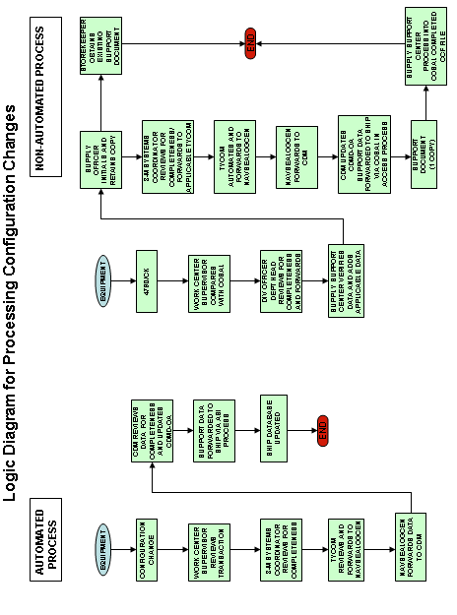

Figure 8-1

8.5.2 Allowance Change Request (ACR)

The ship’s Commanding Officer is responsible for ensuring that sufficient allowance material support is on board to support the current configuration of installed equipment. The ACR process supports this effort.

Interim revisions to allowances are sometimes required in order for shipboard systems o be properly supported. Due to differences in maintenance practices and operating scenarios, allowance for both repair parts and equipment will be subject to selective review and revision. In addition, actual failure rates may excedd original esimates, or circumstances may indicate the need for additional equipment or repair parts. These and other situations may necessitate the submission of an ACR.

The ACR is used to request an allowance revision for repair parts, equipment/components, and equipage. Revisions include range or depth increases or decreases. The ACR Form will be used to submit a request for:

A. Increase an allowed quantity of spares,repair parts, or consumables when the present allowance as indicated in the COSAL is insufficient to meet maintenance requirements.

B. Addition, deletion, replacement of, or revision to the quantity of a portab;e equipment or equipage item on an authorized published allowance list.

C. Addition of a spare part, repair part, or consumab;e item in theship’s allowance which is listed on the APL but did not compute for shipboard stoking under the COSAL computation model used.

ACR’s are submitted via the appropriate TYCOM for approval and then onto Global Distance Support Center for transfer to the applicable ISEA/TSA for their review and approval determination based on engineering expertise. Approved and funded ACR’s will result in an ASI update reflecting the allowance change.

An ACR is not required if increased stocking of a repair part can be substantiated by demand on board a specific ship in accordance with the TYCOM’s Selected Item Management (SIM criteria, unless the item is a Depot Level Repairable (DLR) AND SUBJECT TO A “fixed allowance”.

Allowance Change Request- Fixed (ACR-F)

Depot Level Repairabl (DLR) items are subject to “fixed allowances.” Changes in allowances for these items may be requested by the fleet or TYCOM based on operational experience. Increased stocking of these high cost items must be approved by the inventory manager, normally NAVICP for ships. These changes may be accomplished by using the ACR-F.

If an approved ACR-F pertains to a single ship, the allowance increase will be funded by the TYCOM. If the ACR-F pertains to an entire ship class, the approved allowance increase will e funded by the NAVSEA Technical Operating Budget TOB.

Figure 8-2 provides access to the ACR form through the Portal Areas.

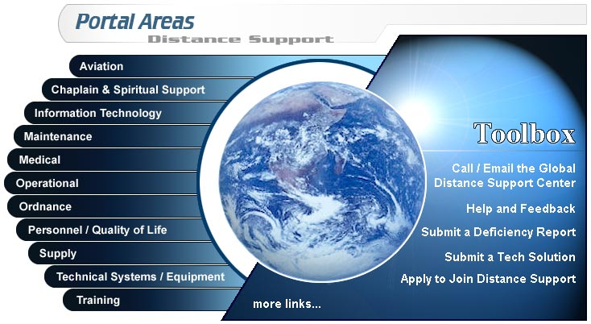
Figure 8-2

Access to the Allowance Change Request Form

ACR’s can be generated electronically through the Anchor Desk at www.anchordesk.navy.mil/Mainmenu.htm (figure 8-2). Select “Submit a Deficiency Report’ and then select “Allowance Change Request (ACR)” web form. An example of an ACR is provided in Appendix 8-A. When an ACR is submitted, the TYCOM field is automatically populated and an email is sent to the TYCOM notifying them that an ACR request has been submitted that requires their attention. In addition to reviewing the ACR, the TYCOM also decides whether the ACR is for one or multiple ship classes. If the TYCOM approves the request, an email is forwarded to the appropriate ISEA and NAVICP for their review and approval determination based on engineering expertise. The process continues with the Naval Sea Logistics Gatekeeper for their review and approval determination, as well as a funding review. At the end of the ACR process, an approved and funded ACR will result in an ASI update reflecting the allowance change, and all parties in the approval/disapproval chain, as well as the submitter, will be electronically notified of the ACR status.

Submission of an ACR provides the Fleet with a method to report a perceived allowance deficiency. If review of the deficiency determines the allowance is incorrect due to improper technical coding, then the technical coding is corrected and the allowance updated for all users of the equipment. If review determines the part is properly supported, then the individual ship should consider augmenting the allowance of this part through the use of Selected Item Management (SIM) procedures or Allowance Change Request – Fixed procedures for Depot Level Repairable (DLR) items.

Figure 8-3 provides the process flow for processing ACRs/ACR-Fs. Extensive distribution of information copies of ACRs is not required. TYCOMS and the requestor of the change will be advised of all actions as the progression of the process continues.

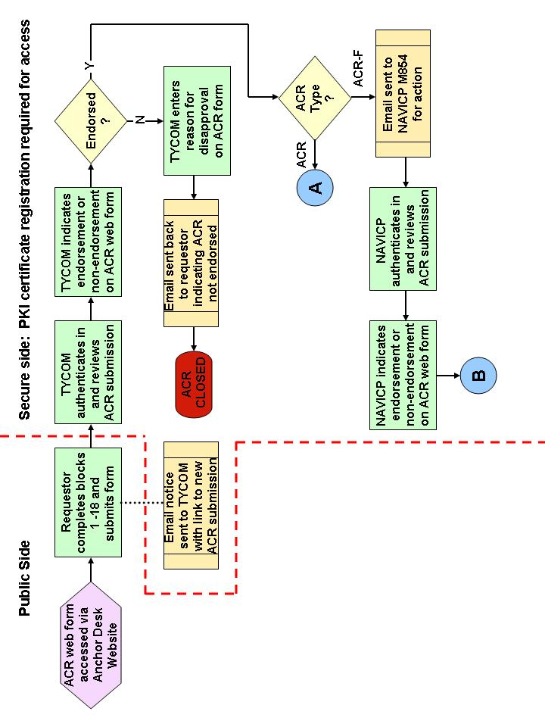

ACR Process Page 1

Figure 8-3

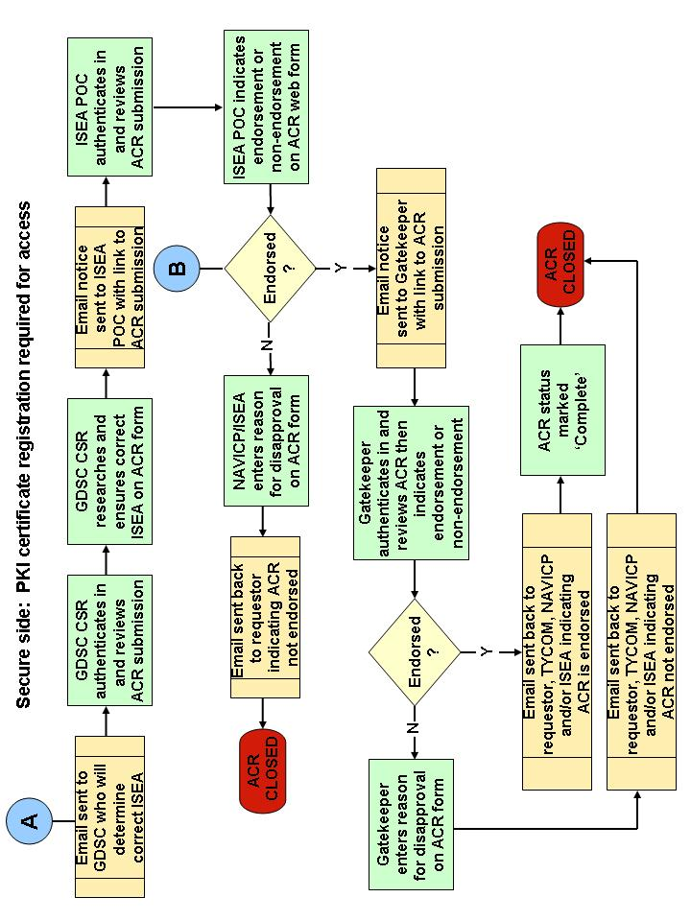

ACR Process Page 2
Figure 8-3
9090-1500

The GDSC reviews the ACRs and electronically forwards them to the appropriate In-Service Engineering Agent (ISEA)/Technical Support Activity (TSA). The ISEA/TSA will review and approve or disapprove the ACRs based on their knowledge of the equipment plus provisioning and allowance requirements. Adequate justification must be provided for an ACR disapproved by the ISEA/TSA.

If an ACR is disapproved, the ISEA notifies the GDSC and the originator. The submitter should be reminded that SIM or ACR-F procedures might be considered as alternatives for items that meet the criteria for stocking in accordance with the guidelines established for those programs.

For approved ACRs, the ISEA/ NAVICP-M coordinates any necessary WSF maintenance and generates an action for the Re-provisioning Gatekeeper to perform a technical review and assess the total cost of the change. The technical review examines configuration data, part usage from Maintenance and Material Management (3-M), redundancy issues, stock status, requisition response time, and other technical factors. After review, the gatekeeper concurs with, requests additional data or recommends alternative solutions. Once final resolution of the ACR is reached, the ISEA notifies the GDSC and the originator of the results.

If the total cost of the change exceeds $50,000, the Gatekeeper checks to see if the OPN 8 Account has funding budgeted for this allowance. If the allowance has not been budgeted for, the Program Office/NAVICP-M is notified and they create and submit a special program funding request to cover the initial outfitting cost. The ship, TYCOM, and GDSC is notified that funding is unavailable to implement the desired allowance change, but a funding request has been submitted.

Once the funding is available or the total cost of the change is equal to or less than $50,000, the gatekeeper notifies NAVSEA 04L4, NAVICP-M manager, NAVICP 01 and the ISEA of the pending action. The ISEA notifies the GDSC and the originator of the execution of the ACR.

For approved and funded ACRs, NAVSEALOGCEN processes the Non-Standard Allowance File (NSAF) record to generate the allowance. NAVICP processes the record that in turn creates an E1 record. The ship’s are notified of the allowance update via ASI and the Srock record File is updated to reflect the allowance change.

ACRs are processed in accordance with the time frames identified in the Processing Time Frames section. When review action cannot be completed within 60 days, an interim reply is furnished to the originator, the TYCOM/NSA and GDSC by the ISEA indicating the expected completion date. Action on an ACR is not considered

complete until final notification of approval or disapproval has been provided to the originator, the cognizant TYCOM/NSA, and any interested TYCOMs/NSAs who received a copy of the incoming ACR.

8.5.2.1 Allowance Change Request Processing Responsibilities

In order to provide for the timely processing of ACRs, the following responsibilities are assigned:

8.5.2.1.1 Commanding Officers

A. Originate an ACR and forwards to the appropriate TYCOM for review and approval or disapproval.

8.5.2.1.2 TYCOMs, Naval Network Warfare Command (NNWC) AND Naval Education and Training Command (NETC)

A. Review all ACRs from the standpoint of propriety and adequacy of information and completeness of technical descriptive data (Note: ACRs for installed equipment are returned to the ship or activity unprocessed). Changes to the configuration of the ship must be handled according to the appropriate alteration process, please refer to the Fleet Modernization Program section.

B. Determine the applicability of the requested change to other ships. ACRs for non-nuclear items applicable to a single ship may be approved by TYCOMs. Single ship approvals are charged to the ship's OPTAR. Single shore activity approvals are charged to the activity's operating funds.

C. Disapprove requests not considered appropriate for further review or that does not meet the usage criteria.

D. Determine if request is applicable for a single ship/class (ACR-F) or additional ships/classes.

8.5.2.1.3 Global Distance Support Center (GDSC)

A. The GDSC serves as the central ACR processing control point.

- A support request is generated for each ACR record.

C. Forward ACRs to the appropriate ISEA/TSA.
D. Maintain a real time database for all ACRs. At a minimum, the database will:

1. Identify which activity is holding and has action on each ACR.

2. Identify approval/disapproval action taken on
completed ACRs, including the date the action was taken.

        - Reprovisioning Gatekeeper

- Gatekeeper performs technical review

1. Demand data to justify allowance increase.

2. Review system design for redundancy.

B. Gatekeeper approves the ACR

1. Ship is buying the part with TOB funds. Gatekeeper loads allowance override and quantity into the NSAF with an ‘A’ override. Create a requisition
trap in ORCAS to prevent the outfitting from paying for the spare.

2. Outfitting account is going to buy the spare.

a. Total cost less than $50K and assets are available to fill requisition. Gatekeeper loads allowance override and quantity into the NSAF. If assets are not available load the pending file with an activation date corresponding to asset available.

b. Total cost in excess of $50K, Gatekeeper confirms sufficient buy out funding is budgeted and assets are available. Gatekeeper loads allowance override and quantity into the NSAF with an ‘A’ override. Total cost in excess of $50K, Gatekeeper determines either insufficient buy out funding is budgeted or assets are not available. The Gatekeeper loads allowance override and quantity into the pending file with an activation date corresponding to funding and/or asset availability.

8.5.2.1.5 Other Processing Control Points

In addition to those ACRs processed, other systems commands and supporting field activities process ACRs for various weapon systems specifically identified in NAVSUP PUB P-485 (Afloat Supply Procedures). Examples include: Navy Medical Logistics Command (NAVMEDLOGCOM) for medical equipment; Naval Air Systems Command (NAVAIR) for aviation and photographic; NAVICP-M for Material Handling Equipment (MHE); and Space and Naval Warfare Systems Command (SPAWAR) for meteorological. PCP responsibilities include:

A. Identifying a single point of contact within the command for the processing of ACRs.

B. Coordinating all ACRs with applicable TSA and ISEA.

C. Forwarding approved ACRs with an estimated value of $50,000 or greater to NAVSEA 04L4 for concurrence/approval.

8.5.2.1.6 Designated ISEA or TSA

A. Identify a single point within the command for each equipment or equipment type to respond to ACRs.

B. Review ACRs.

C. Provide additional technical and engineering information that may be available such as usage data, system specifications, maintenance criteria, and criticality factors.

D. Approve or disapprove those ACRs within the activities' delegated authority.

E. Forward to the cognizant HSC those requests warranting further review at a higher level.

8.5.2.1.7 Hardware Systems Commands

A. Coordinate the development and establishment of policies and procedures relating to all COSAL/OMMS-NG/R-Supply material, and designate technical and engineering activities to perform the responsibilities contained in the Designated ISEA or TSA section.

B. Designate a single point of contact within the HSC and each designated technical or engineering activity for ACR processing control.

C. Review and approve or disapprove ACRs forwarded for decision by PCPs, and return to the initiating PCP in a manner consistent with the time frames established in the Processing Time Frames section.

8.5.2.1.8 Commander Naval Air Systems Command

A. Develop and coordinate policy and procedures relative to NAVAIR managed material included in COSALs/OMMS-NG/R-Supply databases. This includes, but is not limited to: aviation support equipment; air traffic control systems; photographic material; aircraft launch and recovery equipment; and other aeronautical material.

B. Act as processing control point for the NAVAIR managed systems and equipment described above.

C. Coordinate with appropriate SPMs and Ship Logistic Managers (SLMs) to resolve support problems pertaining to NAVAIR managed material.

8.5.2.1.9 Program Executive Office (PEO) or Direct Reporting
Program Manager (DRPM)

A. Coordinate the development and establishment of policies and procedures relating to all COSAL/OMMS-NG/R-Supply material, and designate technical and engineering activities to perform the responsibilities contained in the above paragraph.

B. Designate a single point of contact within the HSC and each designated technical or engineering activity for ACR processing control.

8.5.2.1.10 Commander Naval Sea Systems Command, Deputy Commander
for Fleet Logistics Support (SEA 04L4)

A. Administer the allowance development and revision process.

B. Formulate procedures and policy for COSAL/OMMS-NG/R-Supply allowance development and maintenance.

C. Coordinate policy and procedures among Fleet Commanders, TYCOMs, NNWC, NETC, HSC, CDMs and SPMs.

D. Prepare detailed budget submissions and financial operating plans for COSAL funds, and provide technical and engineering support within approved funding levels.

E. Perform financial management and budget preparation for allowance changes.

F. Advise gatekeeper and other PCPs referenced in the Other PCPs section of funding approval for ACRs with extended cost greater than $50K.

8.5.2.1.11 Navy Inventory Control Point-Mechanicsburg (NAVICP-M)

A. Identify PPRs or Supply Support Requests (SSRs) and estimated material availability dates, i.e., "Buy-out" dates for approved ACRs to NAVSEALOGCEN.

B. Process file changes identified by the ISEA/TSA or revise affected data elements for use in future allowance list computations. Initiate change requests to the Non-Standard Allowance File (NSAF). Upon notification of approved allowance changes, the cognizant inventory manager will initiate appropriate supply support action to include PPRs and SSRs in anticipation of requisitions for the approved item(s).
C. Act as the PCP for ACRs applicable to nuclear propulsion plant equipment based on comments received from SEA 08.

D. Act as the PCP for ACRs applicable to MHE.

8.5.3 Allowance Change Request - New Construction, Conversion, Modernization, and Reactivation

ACRs are also used in ship construction, major conversion, modernization, or reactivation programs to request changes in allowance of repair parts appearing on APLs and equipage appearing on AELs. There are significant differences between those procedures used for active fleet ships and those in new construction, major conversion, or reactivation. Most of these changes are caused by differences in organizational responsibilities, and the need to review and approve requested changes while the ship is within the SCN funding envelope. Figure 8-3 provides the logic for processing ACRs submitted for ships under construction, conversion, modernization, and reactivation. The following paragraphs provide an overview of the primary responsibilities of organizations that process ACRs for new construction, major conversion, modernization, and reactivation programs.

8.5.3.1 Processing Responsibilities

8.5.3.1.1 Prospective Commanding Officers or TYCOM

The Prospective Commanding Officer (PCO) (TYCOM if a PCO has not been designated) will originate the ACR and forward to the NSA for review and evaluation. If the ACR is for a ship(s) beyond the SCN Obligation Work Limiting Date (OWLD), process the ACR in accordance with the OPN procedures provided in the Allowance Change Request section.

8.5.3.1.2 Naval Supervising Activity (NSA)

Only ACRs for ship construction, conversion, modernization, and reactivation programs will be processed by the NSAs. NSA ACR processing responsibilities will vary depending upon whether: (1) the ACR is evaluated for a single or multiple ships, (2) the ACR is evaluated for multiple ship classes, and (3) the ship(s) falling within approved multiple ship ACRs have passed the established SCN OWLD. Consistent with the above criteria, NSA ACR processing responsibilities are as follows:

A. Obtain NSA ACR dollar value approval thresholds from the SPM for each ship class under the cognizance of the NSA.

B. Review and validate ACRs forwarded by ships' PCOs and determine if the ACR should be applied to other ships in the class.

C. For a single ship application, approve/disapprove ACRs where the extended cost is equal to, or less than the authorized dollar threshold established by the SPM.

D. For a single ship application, forward ship ACRs with an
extended cost in excess of the NSA approval authority to the SPM for approval/disapproval.

E. For multiple ship applications, forward all ACRs to the SPM for approval/disapproval.

F. For multiple ship class applications, coordinate the approval/disapproval with the appropriate SPMs.

G. Return all ACRs disapproved by NSA or SPM to the PCO citing reasons for disapproval.

H. Take one of the following actions for approved ACRs:

1. For single ship ACRs, issue the applicable Type II Allowance Appendix Page (AAP) and requisition new allowance items.
2. For ACRs with multiple ship or ship class application - Issue Type II AAP for affected ships and requisition new allowances. Additionally, the NSA will prepare and submit a "Statement of Prior Submission (SPS) - With Differences". The purpose of submitting an "SPS With Differences" is to ensure that the allowance change is appropriately documented in level "C" of the WSF.

8.5.3.1.3 Ship Program Manager (SPM)

A. Coordinate and establish NSA ACR monetary threshold for ACR approval by the NSA.

B. Assist in the review of ACRs for ships undergoing new construction, conversion, modernization, and
reactivation. This responsibility will continue as long as these programs remain in the SCN funding envelope.

C. Approve/disapprove and return to the NSA, multiple ship ACRs, and ACRs that exceed the authorized NSA approval threshold.

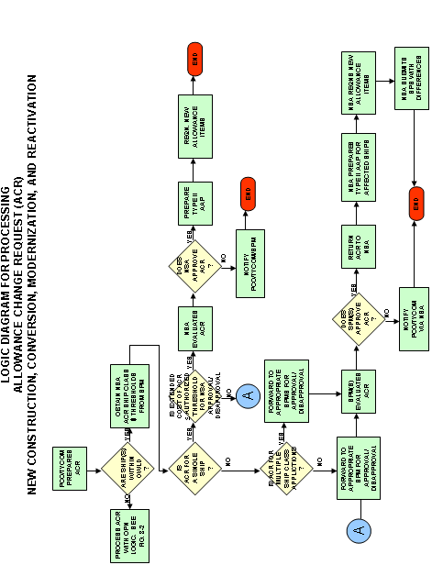

Figure 8-4

8.5.4 Allowance Change Request-Fixed (ACR-F)

DLRs contained in NAVICP-M generated allowance lists are under fixed allowance policies, meaning that the user cannot increase allowance based on demand as with non-DLRs without first obtaining approval. The ACR-F is used to request range/depth changes to fixed allowances when the maintenance demand consistently exceeds the authorized shipboard allowance. Recommended criteria for submitting an ACR-F is at a minimum, two demands within six months.

ACR-Fs are submitted in either of two formats, Naval message or email, depending on the circumstances. A Naval message format is the normal method for requesting changes to the fixed allowances.

The TYCOM performs initial screening and determines if the ACR-F should be approved. The TYCOM approved ACR-F is forwarded to NAVICP-M for final review and approval. Shore activity ACR-Fs other than COSBAL changes will continue to be processed in accordance with NAVICPINST 4440.450B (series).

8.5.4.1 ACR-F Processing Responsibilities

The following paragraphs provide detailed ACR-F processing responsibilities and procedures.

8.5.4.1.1 Commanding Officers

Originate an ACR-F and forward to the appropriate TYCOMfor review and approval or disapproval.

8.5.4.1.2 Type Commanders (TYCOM)

A. Review all ACR-Fs for propriety and adequacy of information and completeness of the technical descriptive data.

B. Determine the applicability of the requested change to other ships.

C. Determine if class-wide or fleet-wide application is
Recommended.

D. ACR-Fs will be charged to the ship or shore activity appropriate funding source.

E. Coordinate responses received from NAVICP-M, which may approve or disapprove the request or may have a request for additional clarifying information.

F. Provide the other TYCOMs with information copies of all ACR-Fs and related correspondence when the request may be of interest to or may have application within their commands.

        - Navy Inventory Control Point – Mechanicsburg (NAVICP-M)

- PM ensures funding is available.

- Ensures PPRs are loaded to support the ACR-F.

C. Work with the ISEA to review ACR-F applicability to
determine stock status.

D. Class Wide approvals greater than $50,000 must be submitted to the RBS Gatekeeper committee for review and approval.

        - In-Service Engineering Agent (ISEA)

- Applicability to ship.

- Check demand.

- Determine if item is scheduled for modernization or alteration.

        - Reprovisioning Gatekeeper

- Gatekeeper performs technical review

1. Demand data to justify allowance increase.

2. Review system design for redundancy.

- Gatekeeper approves the ACR.

1. Ship is buying the part with TOB funds. Gatekeeper
loads allowance override and quantity into the NSAF
with an ‘A’ override. Create a requisition trap in
ORCAS to prevent the outfitting account from paying
for the spare.

2. Outfitting account is going to buy the spare.

a. Total cost less than $50K and assets are
available to fill requisition. Gatekeeper
loads allowance override and quantity into
the NSAF. If assets are not available load
the pending file with an activation date
corresponding to asset available.

b. Total cost in excess of $50K, Gatekeeper
confirms sufficient buy out funding is
budgeted and assets are available. Gatekeeper
loads allowance override and quantity into
the NSAF with an ‘A’ override.

c. Total cost in excess of $50K, Gatekeeper
determines either insufficient buy out
funding is budgeted or assets are not
available. The Gatekeeper loads allowance
override and quantity into the pending file
with an activation date corresponding to
funding and/or asset availability.

8.5.4.1.6 Commander Naval Sea Systems Command (NAVSEA) Deputy Commander for Fleet Logistics Support (SEA 04)

A. Coordinate policy and procedures among Fleet Commanders, TYCOMs, NNWC, NETC, HSC, CDMs, and SPMs.

B. Perform financial management and budget preparation for allowance changes.

8.5.5 Fleet COSAL Feedback Report (FCFBR)

The FCFBR is used to submit a request for correction to a technical problem in a published APL or AEL. It is used to:

A. Report errors or omissions such as wrong or missing manufacturer, nomenclature, technical manual number, stock number, etc.

B. Report discrepancies between part numbers listed in technical manuals and those listed on an APL.

C. Request that a new repair part be added to the range of repair parts listed on an APL (repair parts added as a result of an approved FCFBR will appear in a subsequent APL; but, may or may not be included in the allowance section of a revised COSAL publication, depending on the COSAL computational model used, population, and replacement rate). ‘Not Carried’ parts required for maintenance are now addressed through the ACIP. An FCFBR is not required in these instances. ACIP is described in the Automated COSAL Improvement Program section.

D. Request the deletion of an item incorrectly listed on an APL that is not part of the equipment.

E. Recommend changes in assigned Source, Maintenance, and Recoverability (SM&R) codes, note codes, etc. that are incorrect.

F. Report errors in Circuit Symbol Number (CSN) (e.g., CSN in the Electronics APL Circuit Symbol Number to Reference Number, COSAL Section IIB, crosses to an incorrect reference number or stock number on the APL in COSAL Section IIA).

G. Report inconsistencies between PMS Maintenance Requirements Card (MRC) requirements and corresponding repair part support in the COSAL.

Figure 8-5 provides the process flow for processing FCFBRs.
FCFBRs had been submitted by originators directly to NAVSEALOGCEN for action in the past. However, a recent change to the procedure
now requires all FCFBR submissions to be processed via the Global Distance Support Center web site located at: http://www.anchordesk.navy.mil/fleetsupport/request.nsf/fcfr?openform. Extensive distribution of information copies of FCFBRs is not required. FCFBRs will be processed within 60 days after receipt of request or will be forwarded immediately to the responsible action activity. When the review cannot be completed within prescribed time frames, an acknowledgment will be sent to the originator acknowledging receipt of the FCFBR and indicating the expected completion date. As with approved ACRs, action taken on approved FCFBRs will be included in the NAVICP-M monthly distribution of ASI/CIA data. An example of a FCFBR is provided in Appendix 8-C.

Step-by-Step Procedures for Figure 8-5

1. Originator prepares and submits FCFBR to ship’s work center.

2. Work Center reviews FCFBR in conjunction with…

3. Supply Support Center.

4. If no action is required by shore establishment, FCFBR is
returned to originator.
If off-ship action is required, FCFBR is forward to the GDSC.

5. GDSC reviews and/or evaluates.

5a. Other technical code and/or higher authority assistance
is requested, as required.

6. GDSC forwards to Technical Authority.

7. Technical Authority determines whether an APL/AEL change is
appropriate. If no change is to be performed, originator is notified.

8. NAVICP-M takes required action to update records.

9. NAVICP-M includes update in Quarterly COSAL maintenance action
(ASI/CIA).

10. NAVICP-M develops revised APL/AEL.

11. Change is reflected in subsequent allowance documents
including ASI/CIA.

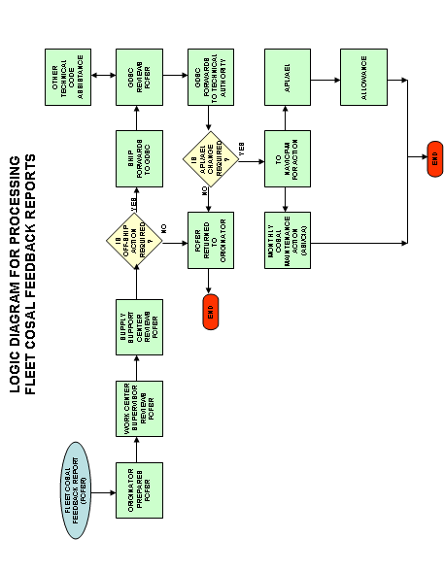

Figure 8-5

8.5.6 Automated COSAL Improvement Program (ACIP)

ACIP identifies/resolves COSAL inaccuracies in the most efficient manner for both forces afloat and the supporting engineering community. It uses existing 3-M data reporting procedures vice the Fleet COSAL Feedback Report (FCFBR) procedures as the source for identifying certain technical inconsistencies in COSAL and allowance documentation for all ships. Under this procedure, 3-M data for “G” and “J” source coded repair parts issues are collected. Source code “G” identifies “Not carried repair parts which are not listed on an APL”, source code “J” identifies “Not Carried repair parts which are on an APL but not in a Stock Number Sequence List or Integrated Stock List”. Shipboard conditions prompting the assignment of these source codes may be indication that COSAL deficiencies related to a specific part exist. The National Item Identification Number (NIIN)/ Allowance Parts List (APL) combination for these records then become a candidate for ACIP review by the cognizant In-Service Engineering Activity (ISEA), Type Commander (TYCOM), or both. The ACIP process reduces the workload on the Fleet sailor by eliminating the requirement to manually generate an *FCFBR for instances when “part is not listed on APL”. At the same time, it enhances the productivity of the shore establishment by allowing consolidated review of problem APLs. For more information on ACIP, including a comparison of the FCFBR program to ACIP, visit the ACIP web page at http://www.nslc.navsea.navy.mil/TechLog/ACIP/ACIP.htm.

The following is a breakdown by Command of the responsibilities under the ACIP program.

1. Naval Sea Systems Command (NAVSEASYSCOM)

- Manage and direct the development, implementation,
Operational, maintenance, and improvements of all aspects
of the ACIP.

- Provide instructions and technical direction for the
management of the ACIP consistent with the requirements of
the Fleet Forces Command (FFC), and TYCOMS.

- Provide technical direction of the ACIP functional efforts at the Naval Sea Logistics Center (NAVSEALOGCEN).

4. Provide policy, instruction, technical guidance to ISEAs.

5. Monitor, evaluate and improve the progress of the ACIP
using on-line reports.

2. Naval Sea Logistics Center (NAVSEALOGCEN)

- Serves as the central data exchange for ACIP data.
- Designs, developes and operates the ACIP application. The application will:

- Consider all the Ships’ 3-M issues that have a
source code of “G” or “J” and a 2nd position fund
code of “R”, “6”, “3” or “B” (e.g., all ships force
level repair parts) and are not already listed on
the APL cited on the issue document as potential
candidates. The actual candidates will be
determined by applying several filters to this
potential list of candidates.

- Compile the ISEA and/or TYCOM responses for each
unique APL-NIIN combination.

- Six times per year, make available via the
web, the ACIP data, combined with WSF data,
to each ISEA and TYCOM for each new APL-NIIN combination under their cognizance.

4. Receive input from TYCOMs regarding ranking of
APLS.

5. Maintain report utilities that enable
NAVSEASYSCOM, TYCOMs, and ISEAs to obtain
desired information related to processing of
ACIP packages. Conduct special analysis upon
request.

6. Make available an Oracle table that contains
all of the source code “G” and “J” items
reported by the fleet that the WSF confirms is
on the APL already and the equipment has
application on the ship. This table will also
contain all the UIC/APL/NIIN data for the
items that have been added to APLs as a result
of ISEA/TYCOM review. The Oracle table is
utilized by the E52 allowance process to
authorize new shipboard allowance quantities.

7. Provide necessary training or assistance to the
ISEAs and TYCOMs.

3. In-Service Engineering Agent (ISEA)

1. Appoint a single Point of Contact (POC) for the
ACIP program.

2. Review each ACIP candidate included in their
tailored package. Assess the need for and complete
necessary provisioning actions for each candidate.

3. Assign the ISEA action code taken for each APL-NIIN
in the ACIP application.

4. Inform NAVSEALOGCEN if APLs should be transferred
to another ISEA for review.

5. Run reports/review metrics/suggest improvements to
process/make changes where needed.

6. Continue to process ‘other’ category FCFBRs.

4. Naval Inventory Control Point, Mechanicsburg (NAVICP-M)

1. Receive provisioning changes from ISEAs, mark reason
for change as FCFBR and take necessary steps to have
the changes go out to fleet as (Pen and Ink) changes
on the monthly ASI and quarterly CIA.

2. Ensure the E52 process (NAVICP’s Allowance Process)
includes ACIP data made available through an Oracle
table to adjust shipboard allowance quantities based
on the results of the ACIP process.

5. Fleet Forces Command (FFC)

1. Provide uniform guidance to TYCOMs regarding
submission of FCFBRs.

2. Insure adequate Fleet Training is available.

3. Review and disseminate effectiveness reports.

6. Type Commander (TYCOM)

1. Provide guidance/training to Fleet regarding ACIP
and FCFBR submissions.

2. Run ACIP reports/review metrics/disseminate
information.

3. Review APL ranking report and provide prioritization
guidance to ISEAs via NAVSEALOGCEN.

4. Review tailored list of candidates updated each
cycle. Assess need to initiate action to revise and
improve support currently provided for the ACIP
candidates. Coordinate corrective actions with
ISEAs, Configuration Data Managers (CDMs), and ships.

8.5.7 Processing Time Frames

Timely processing of allowance change documentation (ACRs,ACR-Fs, and FCFBRs) is essential. Processing time frames vary from 15-60 days depending on the type of change process required.

8.6 CONFIGURATION AND ALLOWANCE UPDATE FEEDBACK TO FLEET SHIPS/ACTIVITIES

    - Configuration and Allowance Update - Non-Automated Ships

Approved configuration and allowance changes are continuously processed into the CDMD-OA database and WSF. Each Quarter the accumulated changes are reported back to affected activities along
with processing and requisitioning aids via a process called CIA. CIA consolidates all "Pen and Ink" changes, New and Revised APLs/AELs, configuration change form adds and changes, plus APL/AEL and X-RIC (a pseudo number used by the CDM to monitor equipment that does not have an APL number assigned). super-sessions into a single report tailored to a given ship/shore activity's allowance document. This product also computes On Board Repair Part (OBRP) allowances based on a given ship/shore activity's specific maintenance level, protection period, and sparing philosophy (i.e., Fleet Logistics Support Improvement Plan [FLSIP], Price Sensitive Modified [MOD]-FLSIP, Readiness Based Sparing [RBS], Conventional, etc.).

The following CIA support package is provided Quarterly to non-automated ships and shore activities:

A. Hull Tailored APL/AEL Change Listing - Furnished in Ship Type/Hull Number Sequence. For each activity, each APL and AEL is listed along with an annotation indicating the type of maintenance action (Configuration change form, New and/or Revised APL/AEL, Pen and Ink Changes, plus APL/AEL and X-RIC super-sessions).

B. Summary of Allowance Component/Equipage/Parts List (SOAPL) - The SOAPL includes all APLs/AELs having update action in the current month's cycle.

C. Part I Index Sections A, B, C, D, and E - Furnished for only configuration change form and APL/AEL/X-RIC super-session actions which generated an APL/AEL during the current month's maintenance cycle. The ship's Job Control Number (JCN)is provided for each configuration change form.

D. Part II Section A (APLs) and Part II Section C (AELs) - Contains a copy of each APL/AEL resulting from 4790/CKs,
new and revised APLs/AELs, line item changes (Pen and Ink) to existing APLs/AELs, and superseded APLs/AELs.

E. Part III Stock Number Sequence List (SNSL) - Provides all allowances resulting from the Quarterly maintenance cycle and is segmented as follows:

1. Part III A - Storeroom Item (SRI) SNSL - allowance determined by considering all National Stock Numbers (NSNs) reflected in Part II (for that month's maintenance cycle) and computed using individual ship's/activity's maintenance level, protection level, and computation model.

2. Part III B - Allowed Operating Space Items (OSIs).

- Part III CF - Allowed MAMs.

F. Part III Section D Alternate Number Cross Reference to National Item Identification Number (NIIN) - Contains additional alternate numbers for the current maintenance cycle.

G. Ship/Activity Value List - Reflects the total dollar value for each COG appearing in the SNSL. Bottom line totals for SRI, OSI, and combined SRI/OSI are also provided.

H. 1114 and 1348M Card Decks - All non-mechanized ships will receive 1114/1348 card decks for SNSL adds and increases.

I. Old to New NIIN Cross Reference List - Provides a cross reference from old NIIN to new NIIN that occurred during the current monthly maintenance cycle.

J. Cancellation/Supersession List - Provides APL/AEL cross reference for superseding APLs/AELs during a monthly cycle. Also provides APLs/AELs that have been canceled during that cycle.

K. Substitute and Interchangeable Cross Reference Records - Provides interchangeable NIINs that can repair/replace
each other and substitute NIINs that can only replace a SNSL NIIN.

L. X-RIC Supersession List - Provides a cross reference from the CDM submitted X-RIC to the superseded APL/AEL.

Detailed procedures on how to process the products provided to the ship/unit via the CIA process are contained in NAVICPINST 4441.170B (COSAL USE AND MAINTENANCE MANUAL).

8.6.2 Configuration and Allowance Update - Automated Ships

On automated ships, the ASI is part of a "closed loop" system to maintain agreement between the ship's OMMS-NG/R-Supply database, CDMD-OA, and the WSF. The CDM updates configuration data in the CDMD-OA database. In a separate action, NAVICP-M updates the WSF with supply and allowance data and new and revised APL coding Best Replacement Factor (BRF), NSN, Source Maintenance & Recoverability (SM&R), Military Essentiality Code (MEC), Mission Criticality Code (MCC), etc.). Both CDM add and change transactions as well as NAVICP-M WSF, APL/AEL updates are captured for a monthly maintenance cycle. The inputs are processed through the NAVICP-M, OMMS-NG/R-Supply programs for generation of a master ASI file. The ASI data is quality reviewed and forwarded to Configuration Data Management Database-Open Architecture (CDMD-OA) central at NAVSEALOGCEN DETPAC where the data is separated by CDM and distributed to the Fleet. The data is up-loaded into the ship's OMMS-NG/R-Supply system via RADWEB; automatically updating the appropriate files with such data as APL characteristics, allowance, stock record, and cross reference information. Allowance adds/increases automatically trigger the ordering of the newly allowed storeroom items charging the NAVSEA Outfitting Account.

8.6.3 Mini-COSAL Updates

Ships may receive special updates to their configurations in addition to the normal Quarterly CIA or Monthly ASI products. A Mini-COSAL is produced and provided to ships when special support reviews or major Ship Changes (SCs) or legacy SHIPALTs are performed outside a scheduled depot level availability. These Mini-COSALs are narrow in scope and address a specific equipment/weapon system or program. Mini-COSALs may be forwarded directly to ships or delivered by the installation team performing the SHIPALT to aid the ship in updating appropriate configuration records and preparing outfitting account requisitions.

8.7 FLEET MODERNIZATION PROGRAM (FMP)

Improvements to ships are distinct from maintenance or repairs, which restore equipment to original operating specifications, rather than enhance capabilities. The Fleet Modernization Program (FMP) provides a structure for the identification, approval, design, planning, programming, budgeting, and installation of military and technical improvements to all ships of the active and
reserve fleets. An improvement is an enhancement to a ship that increases its capability or reliability to perform its assigned mission. A "Proposed Military Improvement" (PMI) enhances specific military characteristics of a ship. A "Proposed Survivability Improvement" (PSI) enhances the ship's ability to sustain its war fighting capability. A "Proposed Technical Improvement" (PTI) enhances safety of personnel, equipment, or systems, and/or increases the reliability, maintainability, or efficiency of installed equipment or systems.

To ensure configuration control and to maintain sound design within Navy ships, all modernization is accomplished by Ship Changes or legacy alterations (i.e., SHIPALTs, ORDALTs, MACHALTs, FCs, etc.). All provide the necessary guidance for the accomplishment of discrete modernization to a ship, as well as standardization of the modernization to simplify repair, logistics support, and damage control.

The FMP process includes:

A. Formal identification of the need for military, survivability, or technical improvements.

B. Review and approval of the requirements for Ship Change Document (SCD) development by competent authority.

C. Development of SCD design and technical information.

D. Identification and procurement of material to support SC installations.

E. Identification and procurement of other initial logistics support elements.

F. Prioritization, programming, and budgeting for the installation of SCs.

G. Recording of SCD impacts into numerous configuration control documents and operating procedures.

H. Recording of information in the Navy Data Environment- Navy Modernization(NDE-NM) database (the official automated database for alteration development, scheduling, material support, and financial data).

I. Programming and budgeting for funds to accomplish all steps in the FMP process.

FMP policy and procedures are fully described in the Fleet Modernization Program Management and Operations Manual (SL720-AA-MAN-010, Volumes I & II) and the SHIPMAIN ONE BOOK. The web
address for the Fleet Modernization Program is: http://www.fmp.navy.mil.

8.7.1 Types of Alterations

There are a number of different types of alterations to ships within the generic term "SHIPALT." Most ship alterations are contained within the FMP. The following is a summary of the different types of SHIPALTs:

FUNDING OF
TYPE DESCRIPTION INSTALLATION

A. Title K Most complex; requires FMP (Shipsheet)
depot level capability

B. Title D Less complex; requires FLTCINC/TYCOM
depot, IMA or Ship’s
Force

C. Title F Least complex; requires FLTCINC/TYCOM
IMA or Ship's Force

D. ORDALT Changes to Naval Ordnance FMP (ORDALT)

E. MACHALT HM&E changes within FMP (MACHALTs)
strict equipment/system
boundaries and with
limited system
ramifications

F. Nuclear Modifications to nuclear FMP (NUCALTs)
Alteration power plants. Controlled
(NUCALT) by SEA 08

G. Field Changes to electronic FMP (SYSCOM)
Change equipment

8.7.2 FMP SHIPALT Accomplishment/Availabilities

Title K SHIPALT installations consume the bulk of FMP funding and manpower, and require extensive advance and production planning; assembly of materials, tools, and installation support documents;

and periods of time during which a ship is free of operational commitments. Most FMP installations occur during CNO scheduled depot level availabilities.

Most FMP Title K SHIPALT installations are accomplished during Complex Overhauls (COHs), Regular Overhauls (ROHs), Extended Refit Periods (ERPs), Selected Restricted Availabilities (SRAs),

Extended Drydocking Selected Restricted Availabilities (EDSRAs), Depot Modernization Periods (DMPs), Continuous Maintenance Availabilities (CMAs), and Phased Maintenance Availabilities (PMAs). These availabilities are scheduled for each ship at the annual Fleet Commander in Chief (FLTCINC) Depot Level Scheduling Conferences. Some elements of the FMP are accomplished outside of these availabilities, but are still funded by the FMP.

8.7.3 FMP Integrated Logistics Support Policy

The activity responsible for procuring new systems and equipment and components intended for shipboard use and for making changes to existing equipment is responsible for procuring or initiating the development of all required logistics support.

This support includes supply support, technical documentation, support equipment, maintenance documentation, and training requirements. This policy applies to Government Furnished Equipment (GFE) and Contractor Furnished Equipment (CFE), including both centrally and locally provided material.

All logistics support products will be complete and accurate. They will be available by Start Of Availability (SOA) and
scheduled for delivery in time to support the installation and testing of the hardware. They will be provided to the ship not later than End Of Availability (EOA). Repair parts support, for locally provided material will be initiated by the Naval Supervising Activity (NSA)/Installing Activity (IA) and requisitioned by the NSA/Integrated Logistics Overhaul (ILO) Team or the ship during the availability.

Technical manuals and test equipment will be procured concurrent with the hardware. Maintenance documentation will be developed by the appropriate NSA/Fleet Technical Support Center (FTSC).

8.7.4 FMP Configuration Update Responsibilities

Providing full ILS to FMP SCs and legacy alterations, to include updating the ship's configuration records during overhauls, requires close coordination and intense interaction between the ship and numerous SYSCOM and Fleet activities. A description of
the responsibilities and functions of key organizations responsible for allowance updates during depot availabilities follows.

8.7.4.1 Naval Supervisory Activity (NSA)/Fleet Industrial Supply Center (FISC)

The NSA or FISC Logistics Reps will provide the support, training, and technical direction to accomplish a variety of configurations and logistics support services on ships during and after industrial availabilities and throughout the operational cycle. The level of support provided to the ship by the NSA/FISC is dependent upon various conditions such as length of availability, COSAL effectiveness, and ship specific requirements.

An NSA/ILO is the process by which a ship’s readiness is improved through training, and the audit analysis and correction of four ILO elements, i.e., the ship’s configuration records, on-board Technical Manual (TM) library, PMS documentation and OBRPs inventory. ILO is traditionally conducted during extended availabilities, such as a Regular or Complex Overhaul (ROH/COH) and is specifically tasked and funded by the TYCOM. For shorter availability cycles, an Integrated Logistics Repair (ILR) may be conducted. An ILR is a phased approach that includes a review of one or more of the four ILO elements.

Primary responsibilities of the FISCs include review, analysis and correction of the ship’s existing configuration records and updating those records with accomplished SC information. While the RMC is responsible for ensuring delivery of technical documentation, such as new TMs and PMs for newly installed equipment, the ship, with the assistance of the FISC, is responsible for requisitioning all new OBRPs requirements when conducting an ILO with OBRPs offload, as well as for identifying and requisitioning OBRP deficiencies of the ship’s force supply inventory. During an ILR, it is ship’s force responsibility to requisition new OBRPs requirements. Further, the FISC identifies and acquires TMs and PMs documentation deficient for non-SC related equipment.

Since the NSA/FISC is the pivotal activity and must provide the ship with a complete ILS package at EOA, it is vital that close coordination and cooperation be maintained between the NSA, FISC, CDM, SPM and the ship. This cooperative interface will assist the NSA/FISC with it’s verification responsibilities; provide the CDM with accurate information for updating the configuration database and enable NSA/FISC to provide the ship with the most accurate and complete logistics support package possible.

8.7.4.2 Configuration Data Manager (CDM)

The CDM has responsibility for maintaining the integrity of the CDMD-OA database. The CDM will monitor and track all ILS milestones within the FMP, maintain the accuracy of all data elements within CDMD-OA, and provide updated information for input to the ship's OMMS-NG/R-Supply database. The CDM is responsible for processing planning data prior to the availability, installation data from the NSA/IA, and corrective data generated during the ILO/ILR review process.

8.7.4.3 Independent Logistics Overhaul (ILO)

The NSAs will assume the ILS functions when it is a CNO availability. Although the SPM has the authority to designate the
NSA ILS function to another activity (i.e., Naval Shipyard, Ship Repair Facility (SRF), typically the NSA will be performed by the applicable Activity depending on geographic area. Accordingly, the NSA IA/AIT is responsible for ensuring that all logistics support is available, as needed, for installation and checkout of systems and equipment. At the completion of installation and checkout, it is the responsibility of the NSA/IA/AIT to assure that all ILS required by the ship for support of newly installed equipment is onboard when the alteration is completed. In those cases when the NSA/IA/AIT acquires material, the NSA/IA/AIT is responsible for procuring all required logistics support. AITs, typically, consist of ISEA or contractor personnel and are tasked by an AIT Manager. The AIT Manager may be the applicable equipment or system Life Cycle Manager (LCM), CNO, the SPM, or the ship's TYCOM.

The NSA/IA/AIT or other activity designated by the SPM is responsible for ensuring the delivery of all required logistics support for all ship availabilities including those involving coordination with an ILO Team and the ship's CDM. The NSA is responsible for verifying the logistics status of all configuration changes by physically validating changes. Within five calendar days of installation or removal, the NSA is responsible for verifying the logistics status of all configuration changes accomplished during the availability. These changes are reported to the CDM using an Installation Report (IR) or Emergent Installation Report (EIR).

8.7.4.4 Regional Maintenance and Modernization Coordination Office (RMC/RMMCO)

A. Act as Alternation Installation Team (AIT)
gatekeeper to the ships.

B. Provide procedures for conducting modernization via
AIT.

C. Verify approval of scheduled alternations.

D. Integrate installation teams with ship’s maintenance
schedules.

E. Ensure the fleet receives the required deliverables
for self sufficiency.

8.7.4.5 Naval Inventory Control Point - Mechanicsburg (NAVICP-M)

NAVICP-M is responsible for ensuring that all FMP centrally procured material managed under their cognizance is fully supported logistically. NAVICP-M provides supply support for Ship Change centrally procured material programmed in the Ship Navy
Data Environment (SNDE), material in the Staged Alteration Material Program (STAMP), and for HSC managed equipment requiring NAVICP-M support. For end items procured by NAVICP-M, support includes technical manuals, drawings, OBRPs, and APL development. The NAVICP-M Alteration PM (NAVICP-M Code 8341) ensures that each element is being accomplished on schedule. Additionally, NAVICP-M provides the following logistics and configuration support:

A. Provisions and builds APLs as needed to support new equipment being installed.

B. Uses Navy Data Environment (NDE) as the authoritative source for all ship availability dates and COSAL report requirements. Allowance products are forwarded to the appropriate NSA/ILO Team and NSA/IA prior to SOA, or as directed by the TYCOM. Automated products generated at TYCOM discretion, are produced for all availabilities in which no COSAL is provided.

8.8 SCLSIS PROCESS DURING EXTENDED INDUSTRIAL AVAILABILITIES

The SCLSIS process directly supports Fleet maintenance and material readiness. It combines previous configuration and logistics management programs into a single integrated system (CDMD-OA) with direct interfaces to OMMS-NG/R-Supply data system. All activities that process configuration and logistics data are part of the SCLSIS network. These activities include Navy ships and shore activities that process data to support the Fleet with an improving level of configuration and logistics support.

The SCLSIS process as it applies to ships in depot availabilities includes:

A. The process by which information concerning alterations, logistics, changes, and discrepancies in the CDMD-OA flows to the CDM, NSA, and NSA/ILO Team.

B. CDM review of configuration and logistics data received and subsequent updating of the CDMD-OA database.

C. Program Manager Representative/On-site Logistics Representative (PMR/OSLR), CDM, NSA, and NSA/ILO Team verifies SCLSIS information.

D. CDM identification of authorized alterations and corresponding logistics support elements to the NSA and NSA/ILO Team.

8.8.1 Pre-Availability Configuration Update Planning

8.8.1.1 Configuration Overhaul Planning (COP)

Configuration Overhaul Planning (COP) is a process encompassing all modernization planning functions necessary to maintain the integrity of the COSAL during and Availability. At approximately SOA-12 months, the system/equipment ISEA will begin Configuration Overhaul Planning (COP) data submission to the CDM for SCs planned during the availability, including AIT installations, with final submission no later than SOA-4. This applies for all installations accomplished either inside or outside of an availability (including any AIT installations occurring during availability, but which are not part of the availability work package). The ISEA is the technical expert responsible for specific systems and, as such, is in the best position to provide the Planning Yard (PY) with the information needed to assure accurate and complete planning data.

The PY or designated activity will prepare the COP Milestone Plan and begin the review of the drawings and schedule for the availability. COP data is further developed by the PY/CDM for use in updating CDMD-OA to reflect the planned EOA configuration for the ship.

8.8.1.2 CDM Evaluates Milestone Plan and Pre-loads COP Data

When the CDM receives COP data from the PY, the CDM will pre-load the ship’s configuration and/or SC records in the CDMD-OA. Before SOA-2, the CDM will ensure the ship configuration records for unconfirmed planned SCs (Installation/ Alteration Status Codes (ISC/ASC) of “J”), to include those submitted by the ISEAs, are loaded in the CDMD-OA. After the receipt of final COP data in the Work Package, but no later than SOA-2, the CDM will change the ISC/ASC “J” ship’s configuration records with ISC/ASC to “P” for confirmed planned SCs. For planned deletes, the CDM will ensure that the ship’s configuration records contain ISC/ASC “E” or “N”.

8.8.1.3 Reconciliation of Databases

When requested by the CDM, the TYCOM will request a copy of the Naval Tactical Command Support System (NTCSS) configuration database Equipment (EQU) file from the ship. The EQU file is provided to the CDM via Revised Alternative Dataflow (RAD) for automatic loading into the Database Reconciliation (DBR) module within CDMD-OA. This file is compared/reconciled with CDMD-OA. The CDM will produce hardcopy Validation Aids (VALAIDS) to validate differences between configuration items in the EQU file and CDMD-OA database. Validations must be performed at the discretion of the SPM/TYCOM and at the ship’s convenience. Activities designated by the SPM or TYCOM will conduct validations and shall report their findings to the CDM, who will update CDMD-OA with the results of this validation.

8.8.1.4 Final COP and Planning Data Submission

At SOA-4, the PY and the Participating Manager (PARM)/LCM/ISEA will submit final COP and planning data for all SCs scheduled during the availability to the CDM. The SOA-4 COP data cutoff date is designed to meet any COSAL production cycle data. The SPM has the option of extending the cutoff date until SOA-15 days.

8.8.1.5 Start of Availability (SOA)

At SOA, the NSA or other SPM designated activity will begin its review of the ship’s configuration and ILS products. The purpose of this review is to identify and correct deficiencies in ILS products and correct configuration record errors. NSA or the SPM designated agent will take necessary action to resolve ILS products deficiencies. Corrections to the ship’s configuration database will be forwarded to the CDM. In addition, the availability/review period will be used to accomplish validations on newly installed/inaccessible equipments that were not validated during the ship’s operating cycle.

The CDM will prepare planned SCs inputs and notify the NSA of completion. As installation/rip-out is completed, the NSA will submit updated records to the CDM via CDMD-OA, including location information. The NSA, or SPM designated agent, will utilize CDMD-OA to notify the CDM of any emergent or unplanned work by submitting an electronic work file, via CDMD-OA, with the required data. Specific data elements are required in order to build a configuration and logistics record within CDMD-OA, to support the ship. The NSA, or SPM designated agent, validates all installed equipment and reports accomplished SCs via CDMD-OA, including any additional information (such as, serial numbers, locations, etc.). Standard data elements on these reports are critical for continuity and completeness in configuration data management. The SCLSIS Technical Specification 9090-700D contains the requirements

for the individual data elements. Updates to the ship’s NTCSS COSAL will be accomplished using the ASI.

8.8.1.6 End of Availability (EOA)

At EOA, the NSA shall list the status of all SCs and any emergent SCs in an EOA Completion Report which is provided to the SPM, CDM and TYCOM. The NSA is also responsible for verification of delivery of all required ILS products. The CDM indicates completion in CDMD-OA with the use of ASC/ISC of “D”/”G”.

8.8.2. Preliminary Allowance List (PAL)

PALs will be developed for systems or equipment without an existing APL for which PTD cannot be obtained and processed by the system or equipment Preliminary Operational Capability (POC) date. PALs are prepared for designated systems or equipment based on
preliminary PTD. After review and approval of the preliminary PTD provided by the NSA or Equipment Acquisition Manager, the Technical Support Activity (TSA) loads Interactive Computer – Aided Provisioning System (ICAPS) with the required data for NAVICP-M. Using ICAPS, NAVICP-M loads information to the WSF. This is an automated files load process that bypasses normal provisioning stations at NAVICP-M. These PALs will be assigned Logistics Support Status Code (LSSC) "BA". The PAL remains in effect until a fully supported APL is developed upon subsequent receipt of PTD. At that time, the LSSC will be upgraded and changed to "AA".

The PAL in no way releases the ISEA or NSA from their responsibility to provide full PTD. The NAVICP-M prepared PAL is forwarded to the TSA. The TSA sends the PAL to the CDM, who provides the PAL to the NSA for processing with other configuration Adds and Increases.

The TSA also advises the Program Executive Office (PEO), Direct Reporting Manager (DRPM), Systems Command (SYSCOM) Commanders, and Program Manager (PM) of the PAL data. The APM uses this data to: (1) procure appropriate numbers of interim repair parts to match computed allowances, and (2) ensure interim repair parts are marked to correspond with the descriptive data on the PAL, e.g., NIIN.

8.8.2.1 Allowance Computation for Configuration Adds and Increases

Every configuration change that is an Add or Increase requires action to supplement the SOA COSAL. After receipt of an interim APL, AEL, or PAL from the NSA, the NSA/ILO Team obtains allowance
update data and documentation from NAVICP-M using the ASI or Mini-COSAL process.

The ASI process is used at all automated NSA/ILO sites. This procedure allows the NSA/ILO Team to request allowance information, tailored to the missing APLs, AELs, and PALs from NAVICP-M. NAVICP-M runs two ASI cycles each month. ASI requests are made using a personal computer loaded with the ASI data entry software package. ASI requests are transmitted via the SCLSIS network to NAVSEALOGCEN Mechanicsburg, PA. NAVSEALOGCEN consolidates the ASI data requests for each semi-monthly cycle and forwards the necessary data sets to NAVICP-M for processing. NAVICP-M extracts a consolidated ASI file and provides it to NAVSEALOGCEN for segregation and distribution to each NSA/ILO site.

The ASI process can also accommodate non-automated ships during an ILO. ILO sites produce hard copy APLs/AELs/PALs and Supply Aids (NAVSUP Forms 1109 and 1114) from the data in the ASI tape. Extracting an ASI does not affect the status of the CDMD-OA database. The ship's CDM retains responsibility for updating these files.

A. Filling out the form:

1. FROM: Pick the Ship’s Name/Hull Number. Ship’s TYCOM/UIC will be automatically filled in by the system.

2. TRACKING NUMBER: Assigned when the request is successfully submitted. You will be emailed (based on the email address you input on the form) a link to check the status for your specific request. A list of ALL submitted ACR requests is also available.

3. DATE SUBMITTED: This is based on the system date upon successful submission.

4. STATUS OF REQUESTED/ALLOWED ITEM: Select one choice from each site of the dotted line.

5. EIC & APL/AEL/RIC: Select your EIC first. Click on the block and a drop-down menu will appear with EIC/APLs specific to your UIC. If the number you desire is not listed select “MY EIC IS NOT LISTED”. Again, if the number you desire is not listed select “MY RIC/APL IS NOT LISTED” If this is the case, then an OPNAV 4790/CK may be required as well.

6. COSAL TYPE: Select the COSAL type for this request from the drop-down menu.

7. NATIONAL STOCK NUMBER (NSN) OR CAGE AND PART NUMBER: Enter the NSN or the CAGE and manufacturer’s part number. The CAGE is to be written in accordance with DoD publications H4-1 or H4-2.

8. EQUIPMENT/COMPONENT(E/C),ITEM NOMNECLATURE, OR ITEM NAME:
Enter nomenclature for each stock number or part number listed in block 7. Provide nameplate description and all available technical data. If the item listed is a repair part and the APL/AEL/RIC number for the parent equipment/component is not provided in block 6, give nameplate data, if available, or as minimum, manufacturer’s name, item name, drawing or reference number, applicable technical manual and the service application system, or subsystem of the equipment which the repair part supports.

9. UNIT OF ISSUE (U/I): Enter the approved abbreviation for each standard item, as listed in the Navy Management Data List (NMDL). For non-standard items, use the manufacturer’s parts list U/I Data.

10. UNIT PRICE: Enter the unit price for each item listed.

11. PRESENT QUANTITY ALLOWED: Enter present quantity allowed (authorized via the ship’s current COSAL/AVCAL). Cite the source and date of allowance document in block 18.

12. NEW TOTAL QUANTITY: Enter the total of the present quantity allowed and the additional quantity requested.

13. EXTENDED VALUE OF CHANGE: New total quantity less present quantity allowed times Unit Price (Computed by system).

14. CURRENT ON HAND QUANTITY: Enter the current Quantity on Hand whether allowed or not allowed.

15. CURRENT ON ORDER QUANTITY (LIST REQN): Enter the current Quantity on Order along with the requisition number.

16. LIST PAST 12 MONTHS DEMAND: Enter any demands (How many times the item was ordered) that have occurred within the past 12 months. Indicate if the item was ordered via a CASREP (box 16a) by selecting “Yes” or “No” after the quantity and indicate if the demand has been recurring/nonrecurring (box 16b).

17. JUSTIFICATION:

  - Tech Manual Number: Fill in appropriate data.
  - Circuit Symbol: Fill in appropriate data.
  - Describe Impact on Ship: Fill in appropriate data.
  - Applicable to other ships/classes – Yes or No, if “Yes” then enter class.
  - Name Plate Data for non-NSN Data: Fill in appropriate data.
  - Justification: Indicate authority for present quantity allowed (Block 12) and reason for requesting change.
–Mandatory-

18. SUBMITTER INFORMATION: Provide name of submitter, DSN and Commercial Telephone Number, and email address. –Mandatory-

THE DATA BELOW IS ENTERED AFTER REQUEST IS SUBMITTED.

19. TYCOM SECTION: TYCOM POC will be auto populated. The identified TYCOM will be required to Endorse/Non-Endorse the request, Select the ACR Type, concur with requestor’s Quantity Change selection in box 12, and add comments that will be emailed back to the requestor.

20. ISEA SECTION: ISEA should select either “Endorsed” or “Non-Endorsed” block. If the ISEA does not endorse the ACR/ACR-F, then a reason must be entered in the comments block that will be automatically emailed back to the requestor.

21. NAVICP-M SECTION: NAVICP-M should select either “Endorsed” or “Non-Endorsed” block. If the NAVICP-M does not endorse the ACR/ACR-F, then a reason must be entered in the comments block that will be automatically emailed back to the requestor.

22. RE-PROVISIONING GATEKEEPER SECTION: Gatekeeper’s POC name, DSN/Commercial Telephone Number, and email Address will be automatically filled in by the system. After review, Gatekeeper should select either the “Endorsed” block or “Non-Endorsed” block. If the Gatekeeper does not approve the ACR/ACR-F, then a reason must be entered in the comments which will be emailed back to all participants. Gatekeeper should also indicate if funding is/isn’t available, Gatekeeper should enter a date, if known, when the funding will become available.

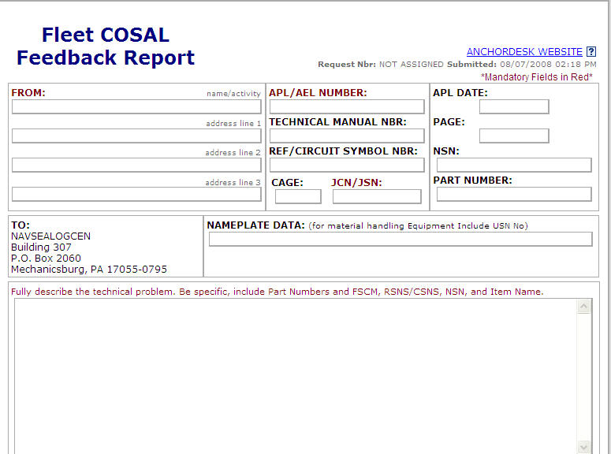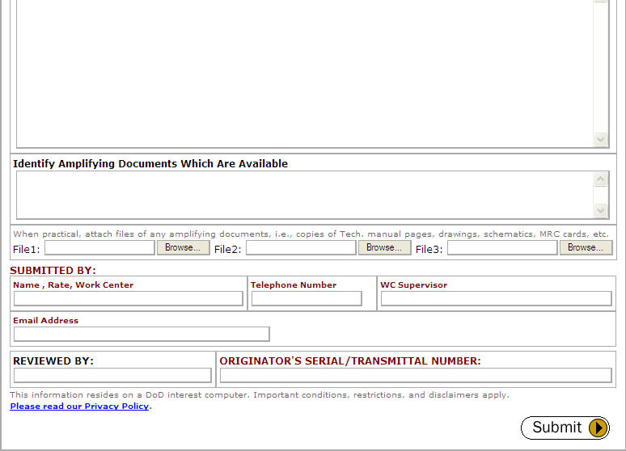

APPENDIX C FLEET COSAL FEEDBACK REPORT

Some conditions under which this Fleet COSAL Feedback Report should be used:

- The part/item is not listed on the APL/AEL but is considered to be a “maintenance significant item.” (Note: This condition precludes the item from being considered for onboard stocking.)*

- Suspected error in code assignments, e.g., SMR Codes, Note Codes, etc.

- Non-allowed part required for PMS.

- Part number in technical manual does not agree with APL.

- Allowed quantity insufficient for PMS requirements.

- APL incomplete (missing information), i.e., characteristics data, technical manual number.

- APL technical problem such as incorrect minimum replacement unit (MRU) assignment.

- Incorrect part/item listed on APL/AEL.

- Source, Maintenance, and Recoverability Codes and Allowance Note Codes noted on APL/AEL are not defined in any publication held.

- Circuit symbol number in Electronics APL Section B crosses to incorrect reference number/stock number.

In general, this report is used to call attention to and seek correction of any technical deficiencies found on APL/AELs. It is not used to report equipment configuration changes. (Use Ship’s Configuration Change Form, OPNAV Form 4790/CK for this). It is not used to request a change in allowance for repair parts or equipage (Use an ACR Form 1220-2 for this) except in those cases when the allowance problem is caused by a technical deficiency in the COSAL (e.g., incorrect MRU assignment, PMS requirement not reflected in SNSL/ISL). See NAVICPINST 4441.170B for detailed information concerning use of this form.

NOTE: The Fleet COSAL Feedback Report should not be used to address matters relating to the Nuclear Reactor Plant COSAL (“Q” COSAL).

Distribution:
Original to NAVSEALOGCEN Code N42
Copy to Ship’s Supply Officer
Copy retained by Originator

0108-LF-501-3710
*With the initiation of ACIP, 3-M data will be used to add items to an APL. Hard copy FCFBRs are not required for this category of change.

APPENDIX D ALLOWANCE CHANGE REQUEST PROCESSING CONTROL POINTS

System/Equipment Processing Control Point

ACR-F NAVICP-M

Aeronautical Material as follows:

Aviation Support Material NAVAIR (AIR 412)

Air Traffic Control Equipment NAVAIR (AIR 412)

Aircraft Launch and Recovery NAVAIR (AIR 412)
Equipment

Photographic Material NAVAIR (AIR 412)

All Other Aeronautical Equipment NAVAIR (AIR 412)

Communications Equipment, Visual
and Portable See OPNAVINST C2300.44D

Deep Submergence NAVSEA (PMS 395)

Electronics (SPAWAR) NAVSEALOGCEN

HM&E and NAVSEA Electronics NAVSEALOGCEN
(SONAR, RADAR, etc.)

Material Handling Equipment (End Item) NAVICP-M 036 (See
SPCCINST 10490.2 and
10490.3)

Material Handling Equipment (Repair NAVICP-M (0341)
Parts)

Marine Corps Aeronautical Material SPAWAR PD 70

Medical NAVMEDLOGCOM

Meteorological Equipment SPAWAR (PD 40)

System/Equipment Processing Control Point

Night Vision Devices NAVSEA 91W21 (see
NAVSEAINST 8215.1)

Ordnance/Fire Control NAVSEALOGCEN

Ordnance Handling Equipment NSWC IHD Det Earle,
E413EZ

Portable Electrical/Electronics Test NAVSEA (SEA 041)
Equipment.

Radiac NAVSEA (SEA 04R)

Special Warfare Equipment NAVSEA (PMS 340)

