APPENDIX B

ALLOWANCE PARTS LIST
PREPARATION AND PROCESSING

Table of Contents

6-B.0 INTRODUCTION
6-B.1 APL DEFINITION
6-B.2 APL PREPARATION
6-B.3 APL FORMAT
6-B.4 TYPES OF APLS
6-B.4.1 Hull, Mechanical and Electrical APL
6-B.4.2 Ordnance APL
6-B.4.3 Ordnance Alteration APL
6-B.4.4 HM&E Machinery Alteration APL
6-B.4.5 Electronic and Gunfire Control System APLs
6-B.4.6 Electronics Field Change APL
6-B.4.7 Miscellaneous Repair Parts List APL
6-B.4.8 Allowance Components List
6-B.5 POLICY 15
6-B.6 RESPONSIBILITIES 15
6-B.6.1 NAVSEA 04L 15
6-B.6.2 Ship Program Manager (SPM) 15
6-B.6.3 Participating Acquisition Resource Manager (PARM) 16
6-B.6.4 Naval Supervising Activity (NSA) 16
6-B.6.5 Naval Inventory Control Point-Mechanicsburg 16

6-B.0 Introduction

This appendix provides specific instructions for the preparation and processing of Allowance Parts Lists (APLs). It implements the policies and procedures pertaining to APLs as set forth in PAFOS Manual Chapter 6. This appendix defines APLs, identifies APL categories, and provides procedures to be followed in the preparation of APLs.

6-B.1 APL DEFINITION

The APL is a technical document jointly prepared by the Technical Support Activity (TSA) and the Naval Inventory Control Point-Mechanicsburg (NAVICP-M). The APL is a stand alone allowance document that identifies a system or equipment and the repair spares, Maintenance Assistance Modules (MAMs), and special tools required for operation and maintenance, both corrective and preventive, for the system or equipment. An APL culminates the provisioning data development and is the document used to establish supply system stockage objectives, as well as define candidates for shipboard allowances. APLs are an integral part of a ship’s Coordinated Shipboard Allowance List (COSAL). APLs that support systems and equipment installed in a ship are listed in the Summary of Effective Allowance Parts/Equipage List (SOEAPL) Part I and are provided in their entirety in Part II of the COSAL.

6-B.2 APL PREPARATION

Chapter 3A of the COSAL Use and Maintenance Manual, NAVICP Instruction 4441.170 (series), identifies and provides examples of the various types of APLs that appear in a COSAL. The preparation of an APL involves multiple actions on the part of the provisioning team summarized below and treated in detail in PAFOS Chapter 4 (Provisioniing):

a. A Ship, System or Equipment acquisition manager contracts for provisioning data.

b. The system or equipment manufacturer or system integrator provides the provisioning data in the format specified by the associated Contract Data Requirements List (CDRL).

c. Provisioning data is processed by the designated TSA and NAVICP-M for the application of technical and supply coding. (See PAFOS Chapter 4, Provisioning, for a full description of the provisioning process and assignment of responsibilities.)

d. Once the data is entered into the Weapon Systems File (WSF) it can be extracted as a stand-alone APL or as part of a COSAL. Stand-alone APLs are commonly referred to as provisioning APLs and show quantities of repair spares, MAMs, and special tools based on the number of equipment installed in a ship. Hard copy COSAL APLs do not list allowed quantities. Instead, the user is referred to the Stock Number Sequence List (SNSL) of the COSAL to determine the allowed quantities.

e. After preparation, the TSA is responsible for the validity of the APL.

6-B.3 APL Format

The APL is formatted as follows (the upper case letters represent the standard blocks on the APL form). Figure B-1 provides an illustrated APL with the applicable data defined:

- EQUIPMENT NOMENCLATURE - This block identifies the system or equipment the APL supports.
- TECHNICAL DOCUMENT NUMBER - This block identifies the system or equipment technical manual and/or system or equipment drawing used to maintain and operate the system or equipment.
- IDENTIFICATION NUMBER - This block provides the APL number assigned. Ordnance Fire Control Systems and Electronics systems have (8) eight characters. Hull, Mechanical, and Electrical (HM&E) equipment have (9) nine characters. Use of APL prefixes and suffixes can expand the number to a total of (11) eleven characters. Allowance Equipage Lists (AELs) have (10) ten characters. Appendix C of the COSAL Use and Maintenance Manual, NAVICP Instruction 4441.170 (series), provides a complete breakdown of HM&E APL categories and the numbering system used in assigning APL identification numbers.
- DATE - The date appearing here is the date the APL was extracted from the WSF.
- PAGE - The page number appearing here is the page number of the APL. The last page of the APL will have the word "END" printed in bold print in the center of the page on the line immediately following the last line of data. This data is entered during the provisioning process.
- CHARACTERISTICS - A finite description of the system or equipment is printed in the body of the APL directly beneath this word. This block can also be used to provide specific instructions and notes. The Commercial and Government Entity (CAGE) for the system or equipment is also provided in this block. This data should also appear on the system or equipment nameplate that is permanently affixed to the system or equipment.
- ADDITIONAL DATA FIELD - The space immediately beneath and following the characteristics field is reserved to provide additional data that helps to identify the system or equipment in relation to a parent system or equipment. This data can consist of additional drawings, additional technical manuals, related APLs, and specifications. This field is also used to record key logistics information and notes pertaining to this APL and its spare parts. The Lead APL (LAPL) for HM&E systems and equipment is identified in this space.
- ACCESSORY EQUIPMENT - APLs for accessory equipment are listed on parent APLs. These accessory APLs are provided through the WSF but must be verified by the TSA.
- REFERENCE SYMBOL NUMBER - This is the plan and piece number or a specific designator assigned to an electronics or fire control system piece part. This number is technical in nature and must be provided by the system or equipment manufacturer and should be an integral part of the system or equipment drawings.
- ITEM NAME - The CAGEs and noun names of embedded parts or special tools are provided in this column. The CAGE is a code assigned to a manufacturer and is an integral part of the design plans and provisioning data. A combination of the CAGE and the plan and piece number of the part provides cataloging data and finite parts identification.
- STOCK NUMBER - The National Stock Numbers (NSNs) or Navy Item Control Numbers (NICNs) assigned to individual parts, special tools, or MAMs are provided in this column. NSNs are assigned by the Defense Logistics Information Service (DLIS) based on the CAGE and part identification provided by NAVICP-M via ICAPS during the provisioning process. NICNs are assigned by NAVICP-M to provide parts identification while an NSN is being obtained. Permanent NICNs may also be assigned to non-stocked items to assist the Fleet in the identification and control of items.
- PART MILITARY ESSENTIALITY CODE (MEC) - The Part MEC is assigned to reflect the importance of each part to the system or equipment as a whole.
- SOURCE, MAINTENANCE AND RECOVERABILITY (SM&R) CODES - SM&R codes are technical in nature and reflect the part level acquisition, maintenance, and disposal philosophies. SM&R code assignment is summarized below and detailed in Chapter 4:
- SOURCE CODE - The Source code consists of the first two digits of the SM&R Code and indicates the source of a part.
- MAINTENANCE CODE - The Maintenance Code consist of two digits occupying the 3rd and 4th positions of the SM&R code.
- RECOVERABILITY/CONDEMNATION CODE - The recoverability/ condemnation code occupies the fifth position of the SM&R code.
- ALLOWANCE NOTE CODES (ANCs) - ANCs are assigned to individual parts to identify a unique requirement of some types, such as MAMs.
- QUANTITY IN ONE EQUIPMENT - The numbers appearing in this column indicate the number of the individual parts that are embedded in the system or equipment identified on the APL.
- UNIT OF ISSUE - This column indicates the quantity of an item carried as a packaging unit in the supply system (i.e., each, assembly, dozen, box, gross, foot, etc.).
- ALLOWANCE ITEM CODE (AIC) - This code provides Allowance Override (AOR) or under-ride coding.
- ON BOARD ALLOWANCE TABLE - If the APL is a provisioning APL, there will be quantities in the columns as applicable. If the APL is extracted as part of a COSAL, the words "SEE SNSL FOR ALLOW" will appear on the face of the APL.
- SHIP TYPE & HULL NUMBER - If the APL is a provisioning APL, this space will be blank. If the APL is extracted as part of a ship's COSAL, that ship's hull type and hull number will be printed in this space (i.e., DD 963 would appear here if the COSAL was for the USS SPRUANCE DD 963).
- PAGE - This space provides the page count on the applicable number of consecutive pages that have been printed by category of APL ("H" indicates HM&E, "Z" indicates ordnance, "E" indicates electronics). For example, the 20th page printed for the HM&E category of APLs would be H20.

6-B.4 TYPEs of APLs

There are several types of APLs. These are described in detail in the COSAL Use and Maintenance Manual, NAVICPINST 4441.170 (series). The APL types are identified here to provide a ready reference. The APL number can range from 8 to 11 characters including prefixes and suffixes.

6-B.4.1 Hull, Mechanical and Electrical APL

HM&E APLs are used to identify the maintenance significant items for HM&E systems and equipment. These APLs have (9) nine characters in their identification number. Figure B-1 is an example of an HM&E APL.

6-B.4.2 Ordnance APL

Ordnance APLs are used to identify the maintenance significant items for the ship’s weaponry and weapons support equipment. These APLs identify the ordnance system by the type of weapon system (i.e., Gun, 5 Inch 54 MK 2 MOD 1, etc.). Ordnance APL identification numbers have (9) nine characters with the first two characters being 00. (See Figure B-2.)

6-B.4.3 Ordnance Alteration APL

This APL is used to identify maintenance significant items supporting an alteration to an ordnance system or equipment. This APL is used in conjunction with the system or equipment APL identified in the characteristics field. Ordnance Alteration (ORDALT) APL identification numbers have (9) nine characters with the first two characters being 0R (zero R). (See Figure B-3.)

6-B.4.4 HM&E Machinery Alteration APL

Machinery Alteration (MACHALT) APLs are developed to identify maintenance significant items supporting configuration changes to HM&E systems and equipment. These changes are caused by redesign of the system or equipment, or by redesign of internal parts. These systems are normally Government acquired and built to NAVSEA specifications. MACHALT APL identification numbers have (9) nine characters and can be identified by an alpha character in the (6th) sixth position. (See Figure B-4.)

6-B.4.5 Electronic and Gunfire Control System APLs

Electronic and Gunfire Control System (GFCS) APLs are developed to identify maintenance significant items supporting electronic and GFCS. These APLs also have a Section "B" which is a topdown breakdown of maintenance significant parts in Circuit Symbol Number (CSN) sequence. CSNs are cross referenced to the NSN or NICN, CAGE for the part, and part number. Electronic and GFCS APL identification numbers have (8) eight characters. (See Figure B-5.)

6-B.4.6 Electronics Field Change APL

Electronics Field Change APLs are prepared to identify maintenance significant items to support the configuration changes resulting from alterations to electronic systems and GFCSs. These APL identification numbers have (8) eight characters. (See Figure B-6.)

6-B.4.7 Miscellaneous Repair Parts List APL

Miscellaneous Repair Parts APLs provide support for a variety of equipment installed in ships that are not APL worthy. These APLs are also used to avoid proliferation of APLs for systems that can be modified by shipboard personnel without changing the configuration of the basic equipment. These APLs, commonly referred to as 89000 series APLs, were developed to accommodate common electrical, piping, and machinery systems. Appendix "A" to the Cosal Use and Maintenance Manual, NAVICPINST 4441.170 (series), provides the ground rules to be used in the development of 89000 series APLs. The identification number for these APLs has (9) nine characters and always starts with "89" as the first (2) two characters. (See Figure B-7.)

6-B.4.8 Allowance Components List

Although the Allowance Components List (ACL) is identified as an APL, the ACL does not identify any parts. The ACL is provided to identify a system that is made up of equipment that are supported by APLs on their own. There are also equipment APL numbers listed that are identified for configuration control purposes only. Some of the equipment listed on the ACL may not be installed at each installation and must be validated for each ship. Parts support for the equipment is derived through the equipment APLs. ACLs are electronic in nature and their identification numbers have (10) ten characters, the last (2) two characters range from "CA" to "CZ" except “X.” (See Figure B-8.)
Figure B-1
Hull, Mechanical and Electrical APL
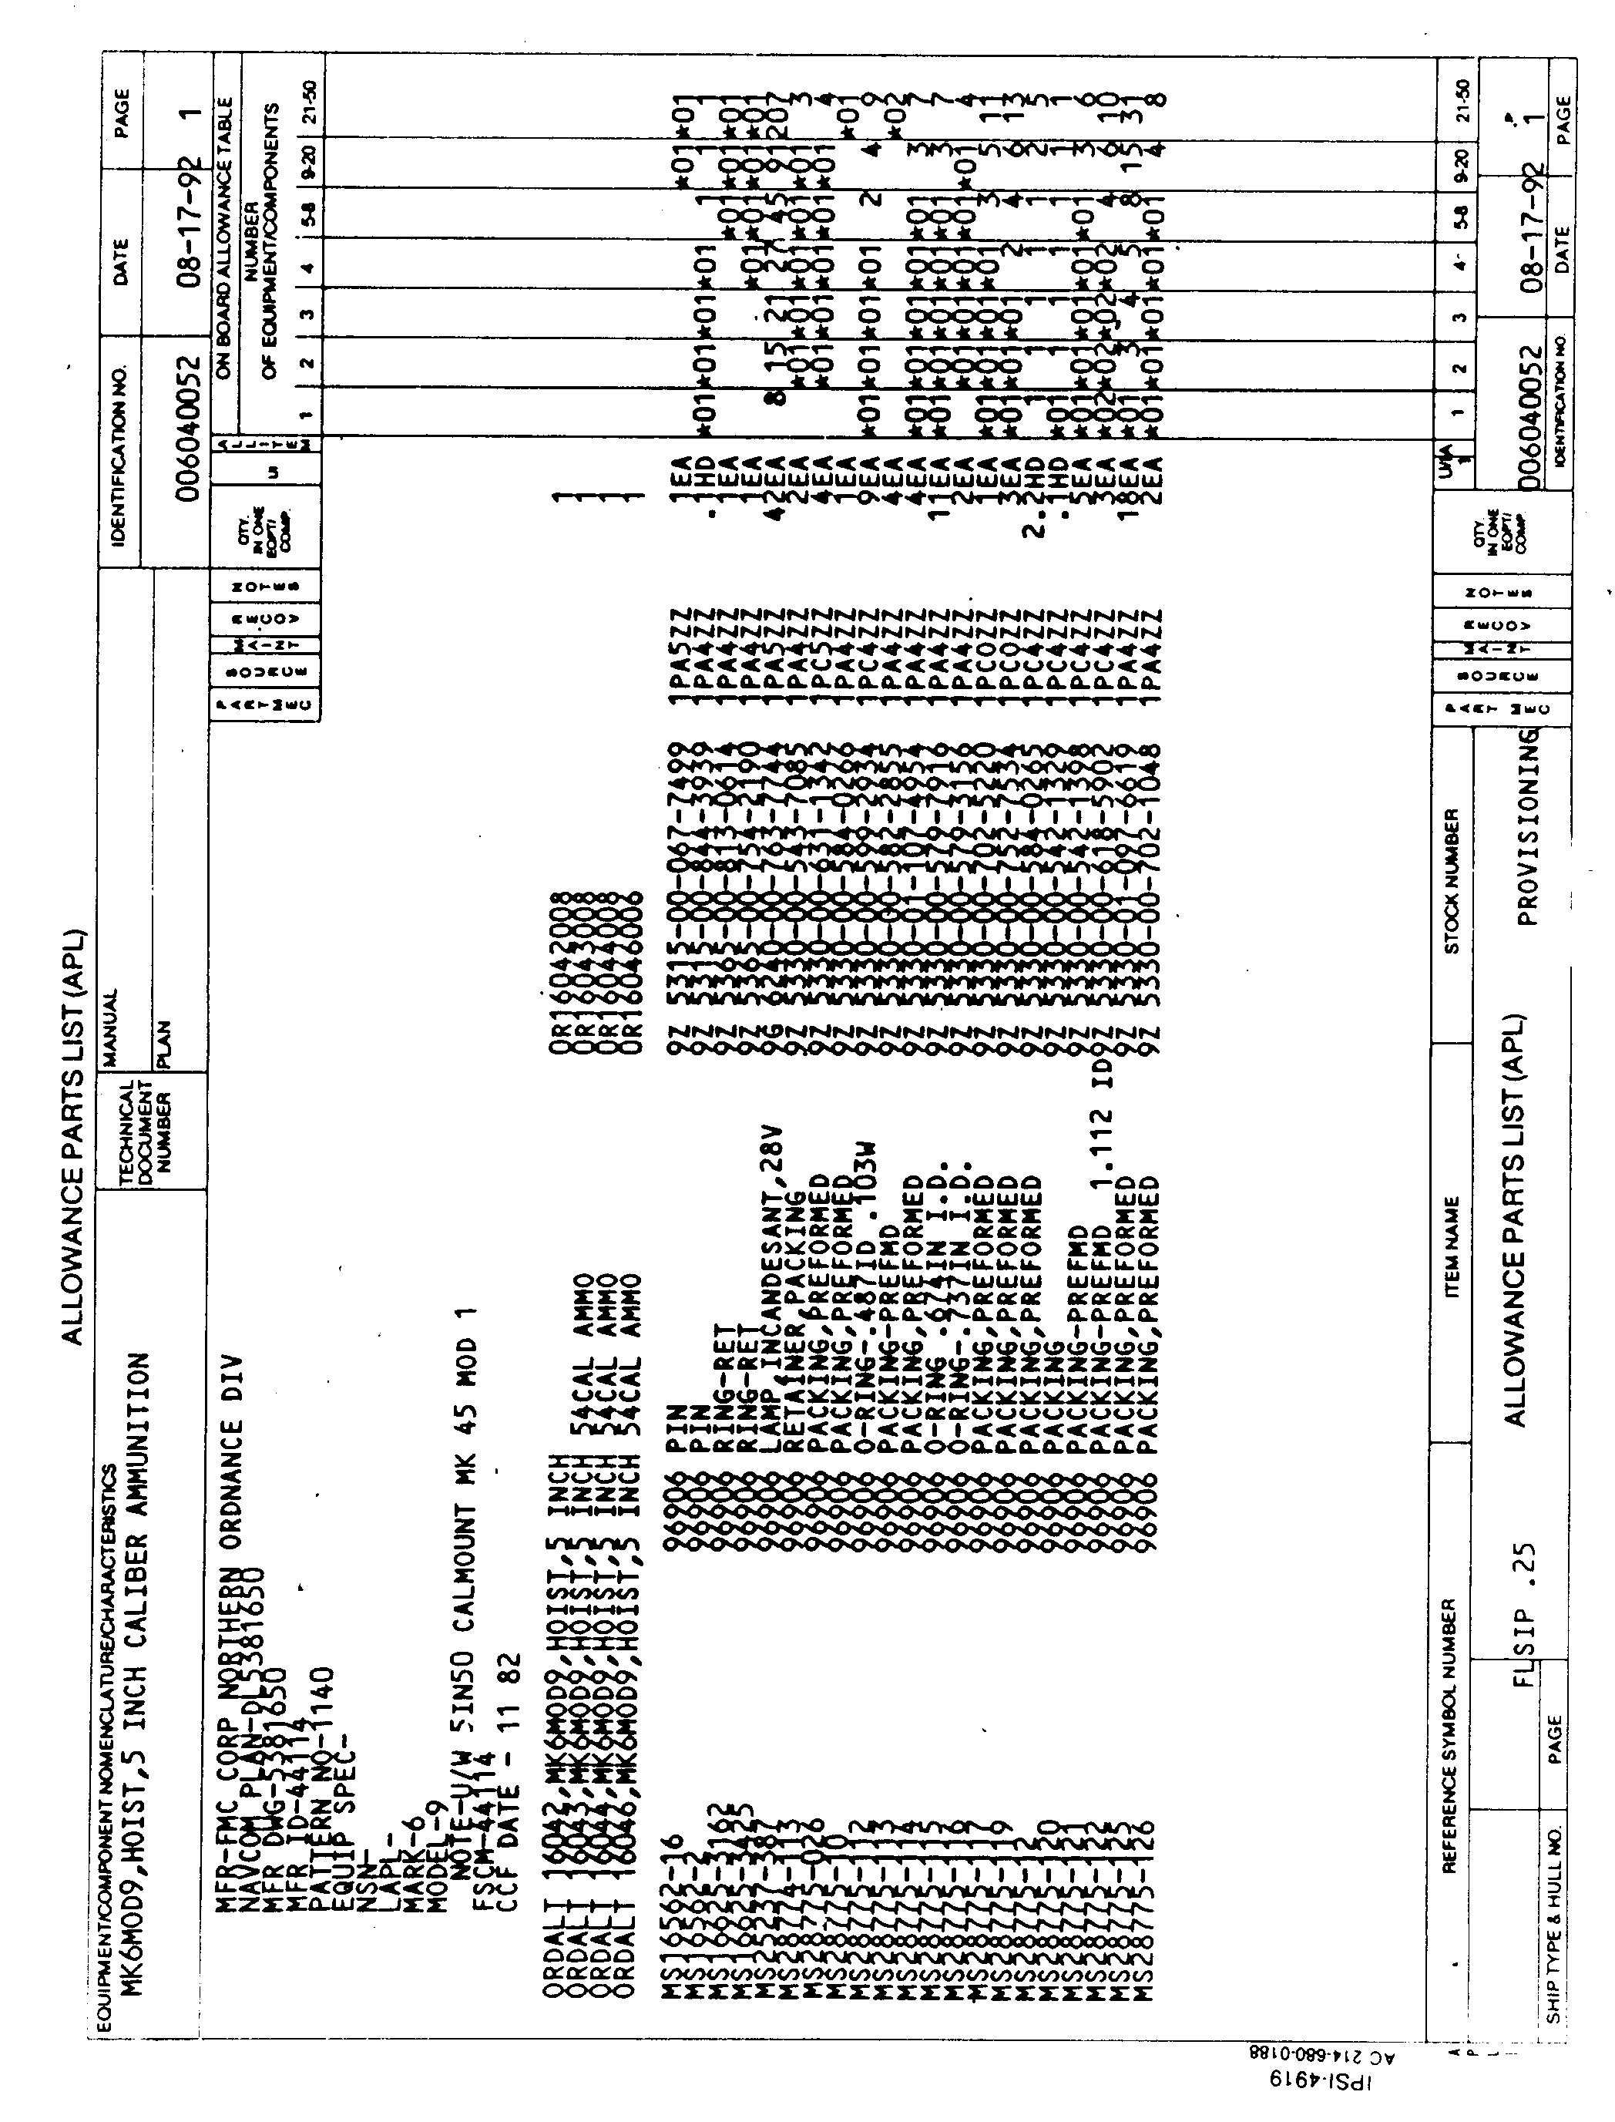
Figure B-2
Ordnance APL

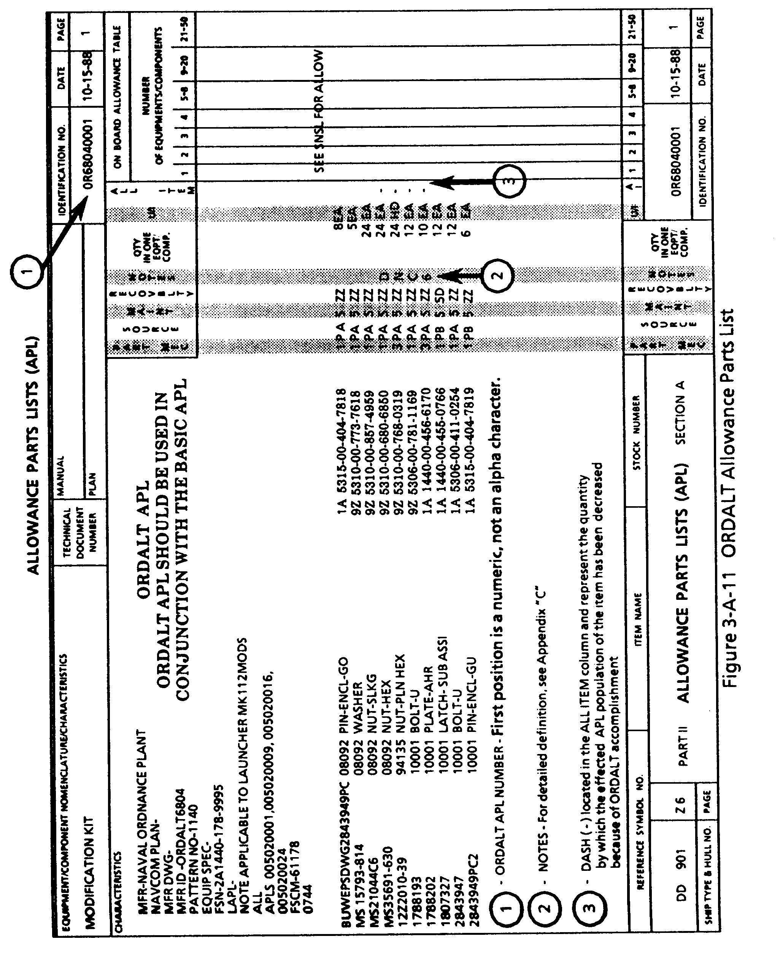
Figure B-3
Ordnance Alteration APL

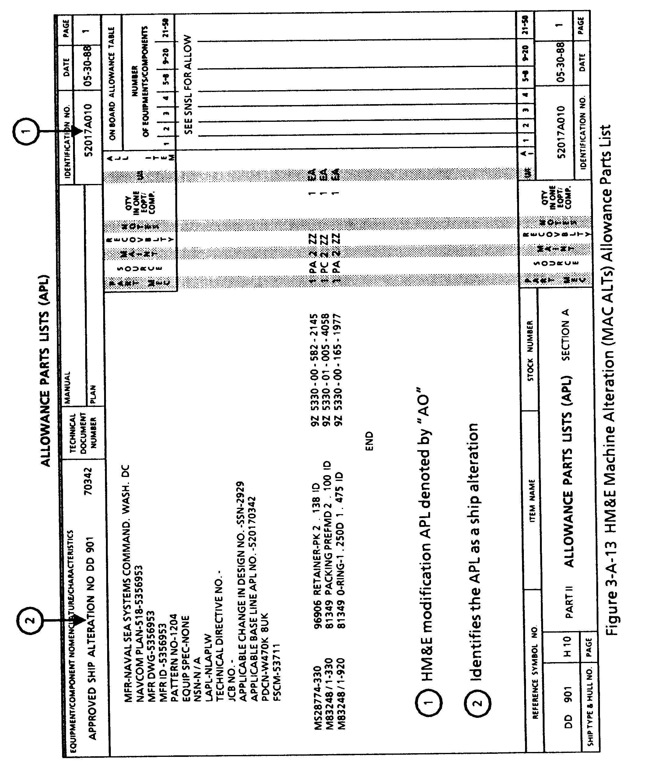
Figure B-4
Machinery Alteration APL

Figure B-5
ELectronic and Gunfire Control System APL
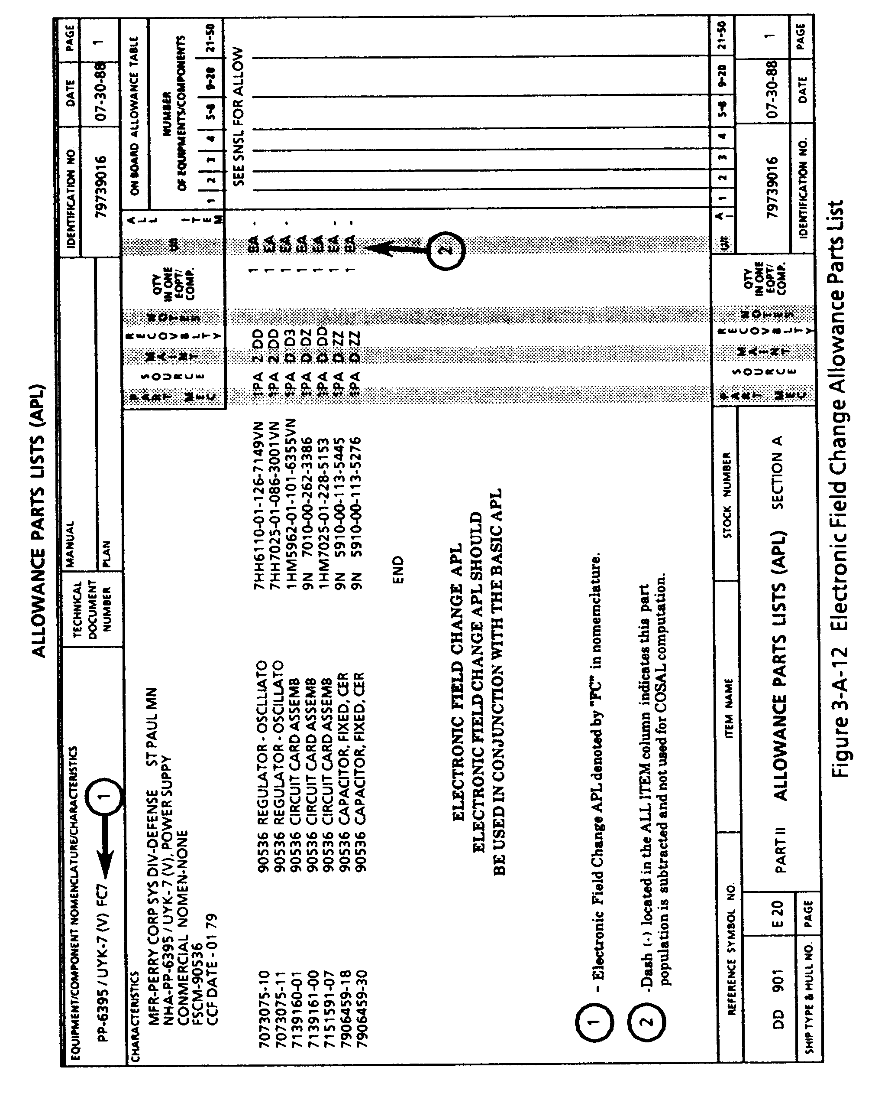
Figure B-6
Electronic Field Change APL
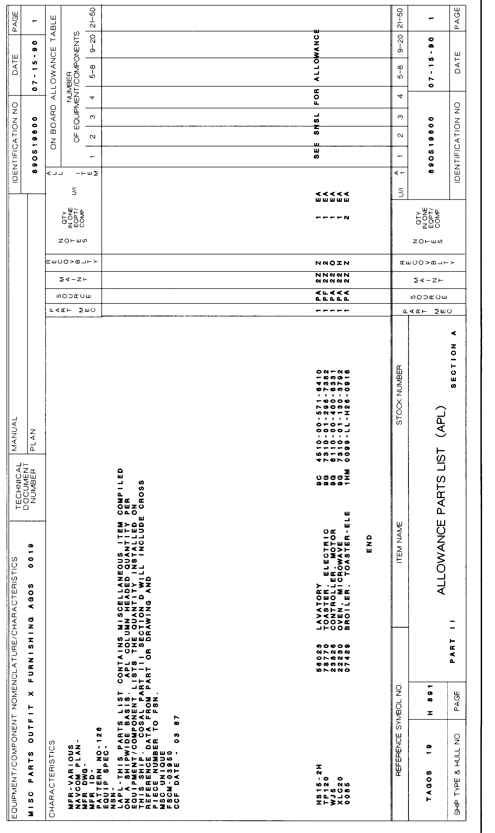
Figure B-7
Miscellaneous Repair Parts List APL
Figure B-8
Allowance Component List
6-B.5 Policy

It is Navy Policy that each system or equipment installed in a U.S. Navy ship be supported by spares, repair parts, special tools, MAMs, plus general and special purpose test equipment necessary to perform maintenance and safely operate the system or equipment. To this end, the following policy shall apply:

- An APL will be developed for each system or equipment that has embedded parts that will be removed, replaced, or repaired on board U.S. Navy ships.

- The TSA shall be responsible for assigning the technical codes and validation of APLs for the equipment under its cognizance.

- The Program Support Inventory Control Point (PSICP) shall be responsible for processing provisioning data and maintaining a file of APL data in Level "C" of the WSF.

- The PSICP shall extract APL data with each COSAL and each update of COSAL data.

A full description of the policy relative to the provisioning process is contained in Chapter 4.

6-B.6 RESPONSIBILITIES

The following responsibilities shall be accomplished by the activities indicated:

6-B.6.1 NAVSEA (04L)

NAVSEA (04L) shall:

- Provide policy and guidance in the preparation of APLs.

- Provide interface with other System Commands to ensure that the provisioning process is completed by the system or equipment installation dates.

6-B.6.2 Ship Program Managers (SPMs)

- SPMs shall require Configuration Data Managers (CDMs) to maintain the correct APLs in the Configuration Data Managers Database-Open Architecture (CDMD-OA) database to reflect the accurate ship configuration and support philosophy.

6-B.6.3 Participating Acquisition Resource Managers (PARMs)

PARMs shall:

- Interface with NAVICP-M to ensure that APLs are developed for each system or equipment installed in a U.S. Navy ship.

- Require Technical Support Activity (TSA) and/or In Service Engineering Agents (ISEAs) to provision certify installed systems and/or equipment to an APL.

6-B.6.4 Naval Supervising Activity (NSA)

NSAs shall provide system and equipment configuration data to the CDM for government procured equipment using the characteristics data provided on the APL to identify the system or equipment.

6-B.6.5 Naval Inventory Control Point-Mechanicsburg (NAVICP-M)

NAVICP-M shall:

- Maintain a database of APL data in the WSF.
- Extract APL data from the WSF for use in computation of a COSAL.
- Provide APL data and/or hard copy APLs to ships as necessary.

